

# 

**Requirement & Design Specification**

**DuDu Media Shopping platform**

**Version: 3.3**

# 

# 

# 

# 

# 

# 

# 

# 

# 

**– Hanoi, November 2023 –**

# **Record of Changes**

| **Version** | **Date** | **A* M, D** | **In charge** | **Change Description** |
| --- | --- | --- | --- | --- |
| V1.1 | 10/9 | A | Team | Create new document |
| V1.1 | 25/9 | A | Đức, Toàn | Add Overview and requirement specification |
| V1.2 | 1/10 | A | Thắng, Tùng | Add Design specification |
| V1.3 | 5/10 | M | Lộc | Complete edit document |
| V2.1 | 17/10 | A | Thắng, Tùng | Add II and III of Iter2 |
| V2.2 | 25/10 | M | Lộc | Complete the document again |
| V3.1 | 26/10 | A | Tùng | Add design specification of Iter3 |
| V3.2 | 28/10 | A | Lộc | Add requirement specification of Iter3 |
| V3.3 | 30/10 | M | Thắng | Complete editing the final document, align, format, add pagination menu |
| V4.0 | 13/11 | M | Thắng | Complete for final presentation |

**\*A - Added M - Modified D - Deleted**

# 

# 

# 

**Record of Changes 2**

**I. Overview 6**

1. User Requirements 6

1.1 Actors 6

1.2 Use Cases 7

1.2.1 Guest Diagram 7

1.2.2 User Diagram 8

1.2.3 Shop-Owner Diagram 9

1.2.4 Admin Diagram 9

1.3 Descriptions 10

2. Overall Functionalities 15

2.1 Screens Flow 15

2.2 Screen Descriptions 16

2.3 Screen Authorization 20

2.4 Non-UI Functions 22

3. System High Level Design 23

3.1 Database Design 23

a. Database Schema 23

b. Table Descriptions 24

3.2 Code Packages 26

**II. Requirement Specifications 30**

1. UC1 - Users List 30

2. UC2 - Restrict Seller 31

3. UC3 - Login 32

4. UC4 - Register 33

5. UC5 - Reset Password 34

6. UC6 - Change Password 35

7. UC7 - User Login with google 36

8. UC8 - Shop Page 37

9. UC9 - Products List 38

10. UC10 - Product Details 39

11. UC11 - Hashtag 40

12. UC12 - Media tab 41

13. UC13 - Comment tab 42

14. UC14 - View Other Profile 43

15. UC15 - Discover 44

16. UC16 - Visit Other User Profile 45

17. UC17 - Search Media 45

18. UC18 - Search Product 46

19. UC19 - MKT Dashboard 47

20. UC20 - Shop Products List 48

21. UC21 - Shop Product Details 49

22. UC22 - Shop List 50

23. UC23 - Feedbacks List 51

24. UC24 - Sale Dashboard 52

25. UC25 - Orders List 53

26. UC26 - Order Details 54

27. UC27 - Shop-Owner Dashboard 55

28. UC28 - Add Coupon 56

29. UC29 - Upload Video with Product Link 56

30. UC30 - Cart Details 57

31. UC31 - Cart Contact 58

32. UC32 - Cart Completion 59

33. UC33 - Feedback 60

34. UC34 - My Orders 61

35. UC35 - Order Information 62

36. UC36 - Edit Profile 64

37. UC37 - User Authorization 65

38. UC38 - Notification 66

39. UC39 - Follow User 67

40. UC40 - Block User 68

41. UC41 - Report Seller 69

42. UC42 - User Profile 70

43. UC43 - Upload Video 71

44. UC44 - Video Manage 72

45. UC45 - Video Dashboard 73

46. UC46 - Messaging 74

**III. Design Specifications 75**

1. Common Features 75

1.1 User Login 75

UI Design 76

Database Access 77

1.2 User Register 77

UI Design 78

Database Access 79

1.3 Reset Password (Forget Password) 80

UI Design 80

Database Access 81

1.4 Change Password 81

UI Design 81

Database Access 82

1.5 User Profile 83

UI Design 83

Database Access 85

1.6 OTP Verify 86

UI Design 86

Database Access 87

2. Public Features 88

2.1 Home Page 88

UI Design 89

Database Access 89

2.2 Product Page 90

UI Design 90

Database Access 92

2.3 Product Details 93

UI Design 94

Database Access 95

2.4 People Profile 96

UI Design 96

Database Access 97

2.5 Shop Page 98

UI Design 98

Database Access 99

3. User Features 101

3.1 Upload Video 101

UI Design 101

Database Access 102

3.2 Cart Details 102

UI Design 102

Database Access 103

3.3 Check Out 104

UI Design 105

Database Access 105

3.4 Check Out 106

UI Design 107

Database Access 107

4. Seller Features 107

4.1 Product Management 107

UI Design 108

Database Access 108

4.2 Shop Management 110

UI Design 110

Database Access 110

4.3 WareHouse Management 111

UI Design 112

Database Access 112

5. Admin Features 113

5.1 Ban User 113

UI Design 114

Database Access 114

**IV. Appendix 115**

1. Assumptions & Dependencies 115

2. Limitations & Exclusions 115

3. Business Rules 116

# **I. Overview**

## **1. User Requirements**

## **1.1 Actors**

| **#** | **Actor** | **Description** |
| --- | --- | --- |
| 1 | Admin | A user with administrative privileges and responsibilities  Can manage and ban users, videos, stores and products based on a list of  reports |
| 2 | Shop owner | Manage shop’s activities, orders of this shop and product management.Shop  owner and also can do whatever an User can do |
| 3 | User | Can see and interact with other Users Video  Have abilities to post videos and watch the newest video on the home page.  Can also add product in cart and buy product in shopping page .Before  buy a product and receive, users can give feedback to that product.  Can see order tracking through order status |
| 4 | Guest | Can only watch public videos in HomePage,and take a look  in the Shopping Page but cannot buy or interact with anything.  Can register to become a user |

## **1.2 Use Cases**

### **1.2.1 Guest Diagram**

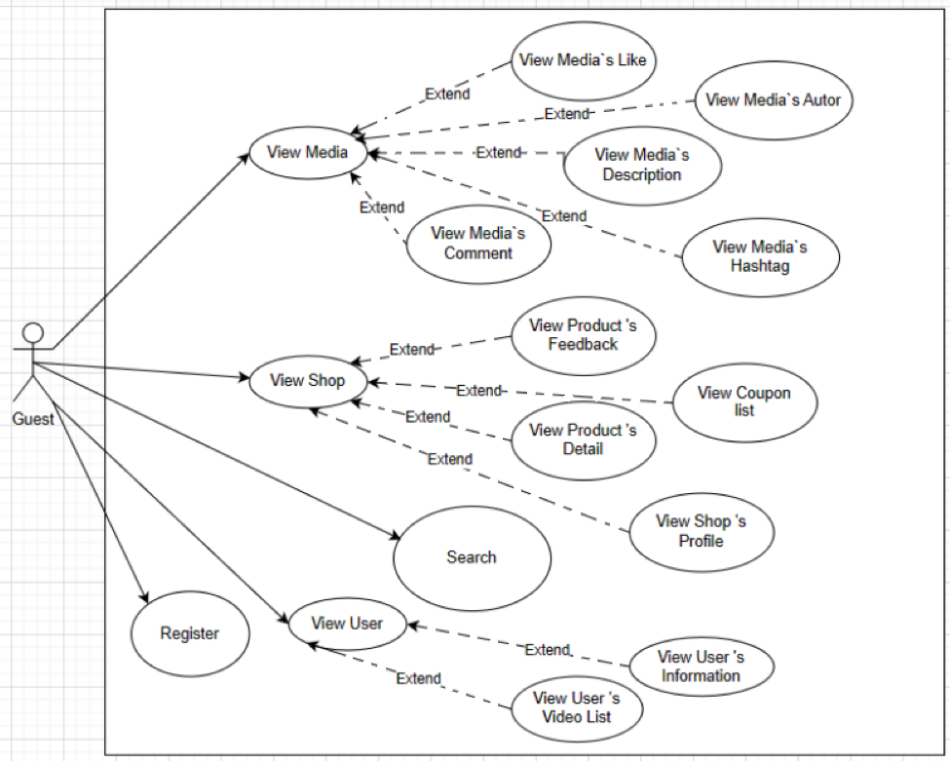

### **1.2.2 User Diagram**

### **1.2.3 Shop-Owner Diagram**

### **1.2.4 Admin Diagram**

#### 

## **1.3 Descriptions**

| **STT** | **Use Case** | **Feature** | **Use Case Description** |
| --- | --- | --- | --- |
| 1 | User List | Admin Feature | Show the paginated list of registered users (include users' id, full name, gender, email, mobile, role, status):  - The admin can search by username  - The list is sortable by id, fullname, gender, email, mobile, role, status ,activity,video  - From each user, the admin can choose to ban or unban them, they couldn't login to the website.And able to delete there video that violate the privacy of web |
| 2 | Restrict Seller | Admin Feature | If the seller's product has too much poor feedback or many buyers complain, the admin will be responsible for checking and making decision to suspend if the seller is truly a scam. |
| 3 | Login | Common Feature | This is a pop-up screen which allows the user to enter username & password to login; on this page, there are also options for user to register new information or reset the password for the case s/he forget it |
| 4 | Register | Common Feature | This is a screen which allows the user to register himself/herself to the system by input following information:first name, last name, username, email,phone number,date of birth, password,confirm password, address, gender, system check if all inputs are valid, if not, display a message line.  User must choose role user or seller  User then need to verify by clicking the link sent via email to him/her before being able to access the system |
| 5 | Reset Password | Common Feature | The user to input his/her username to receive the new password. This password is sent to the user's email for his/her password resetting.  The password of this user will be change in the system to this new password |
| 6 | Change Password | Common Feature | This is a screen which allows the user to change his/her password by inputting his current password as well as new password (twice) |
| 7 | User Login With Google | Common Feature | User can Login or Register with Google,The user's role will default to the user role  User information such as first name, last name, avatar, gmail will be automatically retrieved from Google |
| 8 | Shop Page | Public Fearture | Show sliders, recent products, featured products + the sider with the latest posts, sale information, static contacts/links, all categories.  - Shown slider information includes its image and title  - Shown product information includes its thumbnail, title, rate, and price,the user is redirected to the product's details on his/her clicking |
| 9 | Products List | Public Fearture | Show the products paginated (sorted by updated date, can sort by price and rate) , have the product search box,the sidebar with categories, price and rate filter and can reset all  - Shown product information includes its thumbnail, title, price, shop  - The user is redirected to the product's details on his/her clicking on the product  - Contain the footer have link to social media of company  - Have paging in bottom of page |
| 10 | Product Details | Public Fearture | Show product details (including title, category,slider images,price, and product details) + the sider with relate product:  - Can choose size and type to take the quantity of this from warehouse  - Can change number to add product to cart  - Contain footer about social media link of company |
| 11 | Hashtag | Public Fearture | User can add hashtag in their video and show in the tittle. User can click to this hashtag to go to list of video have this hashtag  - Each hashtag have itself has its own viewing hours and likes, the video have hashtag which have more viewing hours and likes will be up trend ( appear more frequently on users' media tabs) |
| 12 | Media tab | Public Fearture | Show short clip, ads clip that upload from user or shop owner .Each video clip should include name, avatar , description,comment icon, amount of like,share icon,hashtag, product relate to this video post by who posted this video.  Click on the comment icon to go to comment section and click on avata or name to go to profile.  Click Like to like this video, like count of this video will increase  User can click to the button follow to follow other user |
| 13 | View other profile | Public Fearture | Displays other users' information, including name, username, list of videos that person has uploaded, number of followers and following, from this page users can follow and block that user |
| 14 | MKT Dashboard | Seller Feature | Show statistics of products, customers, feedbacks & the trend of new customers by day for the last 7 days (the start date & end date can be adjustable) |
| 15 | Shop Products List | Seller Feature | Show the paginated list of products of a shop(include products' id, thumbnail, title, category):  - From each product, the user can choose toview, edit it  - The page also have the button/link that allows the user to add new product or delete product |
| 16 | Shop Product Details | Seller Feature | Show detailed product information (thumbnail, category, title, brief information, attached images, description, quantity, price), from that allow the user to input, view or edit them  User can add list image of product |
| 17 | Shop List | Seller Feature | Displays a list of all shops owned by the user including name and rate. Users can add new shops with rate name attributes, or can edit or delete their shops. |
| 18 | Feedbacks List | Seller Feature | Show the list of feedbacks paginatedly (include feedbacks' contact full name, product name, rated star, status):  - The user can filter the feedbacks by status, product, rated star + search by full name, feedback content  - Sortable by full name, product name, rated star, status  - From each feedback, the user can choose to view or change it's status |
| 19 | Sale Dashboard | Seller Feature | Show the trend of success/total orders, and the revenues trends by day for the last 7 days for all or a specific sale person (the start date, end date, sale, order status can be adjustable) |
| 20 | Orders List | Seller Feature | Show the list of orders paginatedly  - Each order include below information: id, ordered date, customer name, product (first product name & number of other products if any),type, size , quantity total cost, status;  - Allow the users to filter the order by the order date (from, to), sale name, status  - Allow the user to search the orders by order id, customer name  - User can change status of order from pending to confirmed, processing, dispatched and deliverd, status will be update in order list of customer  - On clicking the link under the order id, user would be redirected to the Order Details page |
| 21 | Order Details | Seller Feature | Show the order details, including the following information:  - Basic order information: order id, customer full name, email, mobile, order date, total cost, status,address  - The receiver information: full name, gendar, email, mobile, address  - This list of ordered products, each product include following information: thumbnail, name, category, price, type and size, quantity, total cost  Sale Manager & the assigned Sale can change the order status & the sale notes |
| 22 | Shop-Owner Dashboard | Seller Feature | Show statistics of new orders (success, cancelled, submitted), revenues (total, by product categories), customers (newly registered, newly bought), feedbacks (average star: total, by product categories) & the trend of order counts (success, all) by day for the last 7 days (the start date & end date can be adjustable) |
| 23 | Add coupon | Seller Feature | Allow seller provide coupon to potential buyers or during events. User can enter coupon code to take discount from the order |
| 24 | Upload video with product link | Seller Feature | Shop Owner can add product above video link |
| 25 | Cart Details | Shopping Feature | Show the cart details with list of the user's chosen products (title, price, type,size,quantity, total cost) and the total order price + the sider with the selection bar to choose shipping way, a box to enter code of voucher to get a discount  The user can  - Change the quantity of each product: the total cost is automatically adjusted  - Choose to delete/remove product by clicking on the deleting icon  - Click the Choose More Product button to go to Products List page  - Click the Check Out button to go to the Cart Contact page |
| 26 | Cart Contact | Shopping Feature | Show the list of user chosen product ( title, price,type,size, quantity, total cost), the total order price and the receiver information (including full-name, mobile, address, notes) for user to edit/input + the sider with the product search box, product categories, the latest products, and static contacts/links  - In case the user has logged in, the receiver information would be filled with the user's information  - The user can click the Shopping Bag button to come back to the Cart Details page for changing the choosing products, click the Order button to submit the order before redirecting user to the Shop |
| 27 | Cart Completion | Shopping Feature | This page show the cart completion notes about order detail  Before this page is shown:  - The Order status is changed to Pending;  - The product's available quantities are updated accordingly  - The customer/user would be received the order confirmation & order detail via his/her email. Those information is shown on the page also. |
| 28 | Feedback | Shopping Feature | On receiving the bought products successfully, the receiver would receive a confirmation email with the guides to feedback on each of the received product; Beside, the user/receive could also give the feedback (on a specific product or general feedback) via the website; The user also call this screen from the system menu on the header;  The feedback information includes contact information (full name, gender, email, mobile), rated star, the attached images and the contact's free-format feedback |
| 29 | My Orders | Shopping Feature | - Show the list of users orders paginated by status of order  - User can choose each status to see all order in this status  - Each order display name, type, size, total price, quantity, small image |
| 30 | Order Information | Shopping Feature | Show the order details, including the information as below  - The order id, order date, total cost, status  - The receiver information: full name, gender, email, mobile, address  - This list of ordered products, each product include following information & the links/buttons that allow the user to re-buy or feedback: thumbnail, name, category, unit price, quantity, total cost |
| 31 | Edit Profile | User Feature | This is a screen which allows the user to edit his/her profile information, including the registered ones & the avatar image.  The user can change role from user to a seller then will be redirect to the Add Shop screen  User can't change email |
| 32 | User Authorization | User Feature | Implementation of authorization mechanism in the system, including the specify the role of logged-in user, his/her authorized page links (building the displayed menu items (in the front end) and preventing unauthorized access via enter the links directly) |
| 33 | Notification | User Feature | Users will receive notifications about discount codes, updated order status, and notifications from the system via email. |
| 34 | Follow user | User Feature | Users can follow other people, increase the number of their followers and their following, videos of the person the user has just followed will appear more on the media tab. |
| 35 | Block user | User Feature | User can block an account, then they will never seen the video from this account evermore in user's media tab, the blocked person's personal page will also be empty |
| 36 | Report Seller | User Feature | This function will show to the customer the report form if the Customer BOUGHT the product. After submit the form, it will send to the Admin to check |
| 37 | User Profile | User Feature | Displays full name, email phone, date of birth, address, age, bio, all uploaded videos of that user, avatar  Displays list of followers, following, user blocked list |
| 38 | Upload video | User Feature | User can upload there video to the platform, while upload user have to input some information like title,video , hashtag.If shop-owner upload video, they will have an option to add a product link to there video.Shop Owner can add there product link to the video they upload |
| 39 | Video Manage | User Feature | Users can view the list of videos they have uploaded, manage it by editing or deleting the video |
| 40 | Video Dashboard | User Feature | Users can view statistics on the number of views, likes, and comments in their videos |
| 41 | Messaging | User Feature | Users can message each other, the chat box will be updated every time one person messages the other, and users can message the shop owner |

## **2. Overall Functionalities**

### **2.1 Screens Flow**

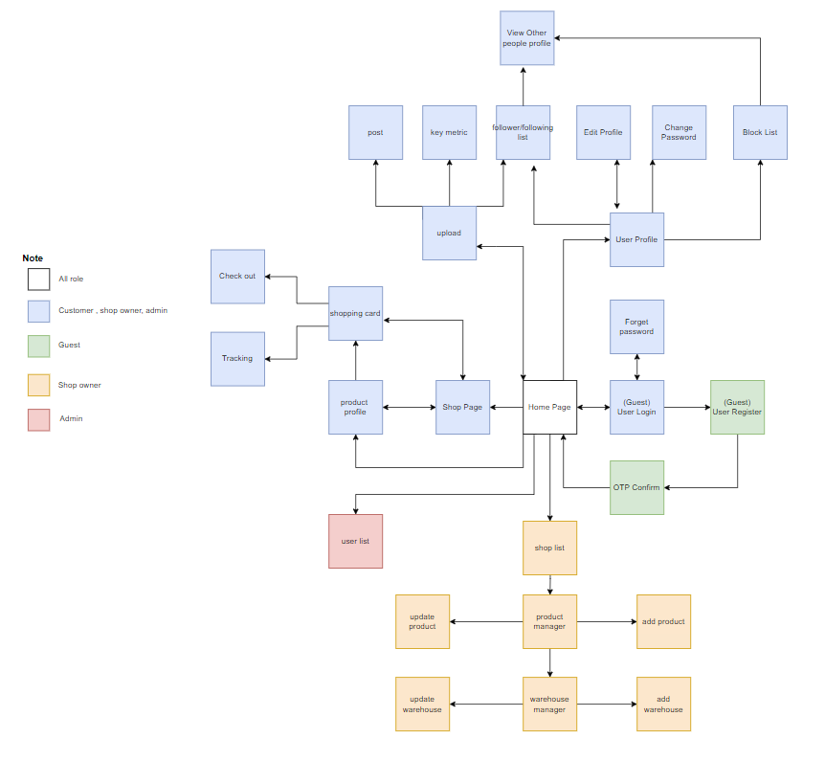

### **2.2 Screen Descriptions**

| **#** | **Feature** | **Use case** | **Use case description** |
| --- | --- | --- | --- |
| 1 | Admin Feature | Users List | Show the paginated list of registered users (include users' id, full name, gender, email, mobile, role, status):  - The admin can search by username  - The list is sortable by id, fullname, gender, email, mobile, role, status ,activity,video  - From each user, the admin can choose to ban or unban them, they couldn't login to the website.And able to delete there video that violate the privacy of web |
| 2 | Admin Feature | Restrict Seller | If the seller's product has too much poor feedback or many buyers complain, the admin will be responsible for checking and making decision to suspend if the seller is truly a scam. |
| 3 | Common Feature | Login | This is a pop-up screen which allows the user to enter username & password to login; on this page, there are also options for user to register new information or reset the password for the case s/he forget it |
| 4 | Common Feature | Register | This is a screen which allows the user to register himself/herself to the system by input following information:first name, last name, username, email,phone number,date of birth, password,confirm password, address, gender, system check if all inputs are valid, if not, display a message line.  User must choose role user or seller  User then need to verify by clicking the link sent via email to him/her before being able to access the system |
| 5 | Common Feature | Reset Password | The user input his/her username to receive the new password. This password is sent to the user's email for his/her password resetting.  The password of this user will be change in the system to this new password |
| 6 | Common Feature | Change Password | This is a screen which allows the user to change his/her password by inputting his current password as well as new password (twice) |
| 7 | Common Feature | User Login With Google | User can Login or Register with Google,The user's role will default to the user role  User information such as first name, last name, avatar, gmail will be automatically retrieved from Google |
| 8 | Public Fearture | Shop Page | Show sliders, recent products, featured products + the sider with the latest posts, sale information, static contacts/links, all categories.  - Shown slider information includes its image and title  - Shown product information includes its thumbnail, title, rate, and price,the user is redirected to the product's details on his/her clicking |
| 9 | Public Fearture | Products List | Show the products paginated (sorted by updated date, can sort by price and rate) , have the product search box,the sidebar with categories, price and rate filter and can reset all  - Shown product information includes its thumbnail, title, price, shop  - The user is redirected to the product's details on his/her clicking on the product  - Contain the footer have link to social media of company  - Have paging in bottom of page |
| 10 | Public Fearture | Product Details | Show product details (including title, category,slider images,price, and product details) + the sider with relate product:  - Can choose size and type to take the quantity of this from warehouse  - Can change number to add product to cart  - Contain footer about social media link of company |
| 11 | Public Fearture | Hashtag | User can add hashtag in their video and show in the tittle. User can click to this hashtag to go to list of video have this hashtag  - Each hashtag have itself has its own viewing hours and likes, the video have hashtag which have more viewing hours and likes will be up trend ( appear more frequently on users' media tabs) |
| 12 | Public Fearture | Media tab | Show short clip, ads clip that upload from user or shop owner .Each video clip should include name, avatar , description,comment icon, amount of like,share icon,hashtag, product relate to this video post by who posted this video.  Click on the comment icon to go to comment section and click on avata or name to go to profile.  Click Like to like this video, like count of this video will increase  User can click to the button follow to follow other user |
| 13 | Public Fearture | Comment tab | Show the comment of the video , amount of like that comment receive.Can click on the name or avatar of user that comment to go to profile tab of that user |
| 14 | Public Fearture | View other profile | Displays other users' information, including name, username, list of videos that person has uploaded, number of followers and following, from this page users can follow and block that user |
| 15 | Public Fearture | Discover | A tab that group video with each hashtag and let user to choose whatever is the tag they will like |
| 16 | Public Fearture | Vist other user profile | Let an user can go to other profile to visit but cannot edit anything. |
| 17 | Public Fearture | Search Media | Users can view statistics on the number of views, likes, and comments in their videos |
| 18 | Public Fearture | Search Product | Users can message each other, the chat box will be updated every time one person messages the other, and users can message the shop owner |
| 19 | Seller Feature | MKT Dashboard | Show statistics of products, customers, feedbacks & the trend of new customers by day for the last 7 days (the start date & end date can be adjustable) |
| 20 | Seller Feature | Shop Products List | Show the paginated list of products of a shop(include products' id, thumbnail, title, category):  - From each product, the user can choose toview, edit it  - The page also have the button/link that allows the user to add new product or delete product |
| 21 | Seller Feature | Shop Product Details | Show detailed product information (thumbnail, category, title, brief information, attached images, description, quantity, price), from that allow the user to input, view or edit them  User can add list image of product |
| 19 | Seller Feature | Shop List | Displays a list of all shops owned by the user including name and rate. Users can add new shops with rate name attributes, or can edit or delete their shops. |
| 23 | Seller Feature | Feedbacks List | Show the list of feedbacks paginatedly (include feedbacks' contact full name, product name, rated star, status):  - The user can filter the feedbacks by status, product, rated star + search by full name, feedback content  - Sortable by full name, product name, rated star, status  - From each feedback, the user can choose to view or change it's status |
| 24 | Seller Feature | Sale Dashboard | Show the trend of success/total orders, and the revenues trends by day for the last 7 days for all or a specific sale person (the start date, end date, sale, order status can be adjustable) |
| 25 | Seller Feature | Orders List | Show the list of orders paginatedly  - Each order include below information: id, ordered date, customer name, product (first product name & number of other products if any),type, size , quantity total cost, status;  - Allow the users to filter the order by the order date (from, to), sale name, status  - Allow the user to search the orders by order id, customer name  - User can change status of order from pending to confirmed, processing, dispatched and deliverd, status will be update in order list of customer  - On clicking the link under the order id, user would be redirected to the Order Details page |
| 26 | Seller Feature | Order Details | Show the order details, including the following information:  - Basic order information: order id, customer full name, email, mobile, order date, total cost, status,address  - The receiver information: full name, gendar, email, mobile, address  - This list of ordered products, each product include following information: thumbnail, name, category, price, type and size, quantity, total cost  Sale Manager & the assigned Sale can change the order status & the sale notes |
| 27 | Seller Feature | Shop-Owner Dashboard | Show statistics of new orders (success, cancelled, submitted), revenues (total, by product categories), customers (newly registered, newly bought), feedbacks (average star: total, by product categories) & the trend of order counts (success, all) by day for the last 7 days (the start date & end date can be adjustable) |
| 28 | Seller Feature | Add coupon | Allow seller provide coupon to potential buyers or during events. User can enter coupon code to take discount from the order |
| 29 | Seller Feature | Upload video with product link | Shop Owner can add product above video link |
| 30 | Shopping Feature | Cart Details | Show the cart details with list of the user's chosen products (title, price, type,size,quantity, total cost) and the total order price + the sider with the selection bar to choose shipping way, a box to enter code of voucher to get a discount  The user can  - Change the quantity of each product: the total cost is automatically adjusted  - Choose to delete/remove product by clicking on the deleting icon  - Click the Choose More Product button to go to Products List page  - Click the Check Out button to go to the Cart Contact page |
| 31 | Shopping Feature | Cart Contact | Show the list of user chosen product ( title, price,type,size, quantity, total cost), the total order price and the receiver information (including full-name, mobile, address, notes) for user to edit/input + the sider with the product search box, product categories, the latest products, and static contacts/links  - In case the user has logged in, the receiver information would be filled with the user's information  - The user can click the Shopping Bag button to come back to the Cart Details page for changing the choosing products, click the Order button to submit the order before redirecting user to the Shop |
| 32 | Shopping Feature | Cart Completion | This page show the cart completion notes about order detail  Before this page is shown:  - The Order status is changed to Pending;  - The product's available quantities are updated accordingly  - The customer/user would be received the order confirmation & order detail via his/her email. Those information is shown on the page also. |
| 33 | Shopping Feature | Feedback | On receiving the bought products successfully, the receiver would receive a confirmation email with the guides to feedback on each of the received product; Beside, the user/receive could also give the feedback (on a specific product or general feedback) via the website; The user also call this screen from the system menu on the header;  The feedback information includes contact information (full name, gender, email, mobile), rated star, the attached images and the contact's free-format feedback |
| 34 | Shopping Feature | My Orders | - Show the list of users orders paginated by status of order  - User can choose each status to see all order in this status  - Each order display name, type, size, total price, quantity, small image |
| 35 | Shopping Feature | Order Information | Show the order details, including the information as below  - The order id, order date, total cost, status  - The receiver information: full name, gender, email, mobile, address  - This list of ordered products, each product include following information & the links/buttons that allow the user to re-buy or feedback: thumbnail, name, category, unit price, quantity, total cost |
| 36 | User Feature | Edit Profile | This is a screen which allows the user to edit his/her profile information, including the registered ones & the avatar image.  The user can change role from user to a seller then will be redirect to the Add Shop screen  User can't change email |
| 37 | User Feature | User Authorization | Implementation of authorization mechanism in the system, including the specify the role of logged-in user, his/her authorized page links (building the displayed menu items (in the front end) and preventing unauthorized access via enter the links directly) |
| 38 | User Feature | Notification | Users will receive notifications about discount codes, updated order status, and notifications from the system via email. |
| 39 | User Feature | Follow user | Users can follow other people, increase the number of their followers and their following, videos of the person the user has just followed will appear more on the media tab. |
| 40 | User Feature | Block user | User can block an account, then they will never seen the video from this account evermore in user's media tab, the blocked person's personal page will also be empty |
| 41 | User Feature | Report Seller | This function will show to the customer the report form if the Customer BOUGHT the product. After submit the form, it will send to the Admin to check |
| 42 | User Feature | User Profile | Displays full name, email phone, date of birth, address, age, bio, all uploaded videos of that user, avatar  Displays list of followers, following, user blocked list |
| 43 | User Feature | Upload video | User can upload their video to the platform, while upload user have to input some information like title,video , hashtag.If shop-owner upload video, they will have an option to add a product link to there video.Shop Owner can add there product link to the video they upload |
| 44 | User Feature | Video Manage | Users can view the list of videos they have uploaded, manage it by editing or deleting the video |
| 45 | User Feature | Video Dashboard | Users can view statistics on the number of views, likes, and comments in their videos |
| 46 | User Feature | Messaging | Users can message each other, the chat box will be updated every time one person messages the other, and users can message the shop owner |

### **2.3 Screen Authorization**

| **Screen** | **Guest** | **User** | **Admin** | **Shop owner** |
| --- | --- | --- | --- | --- |
| Home Media | **X** | **X** | **X** | **X** |
| Login | **X** | **X** | **X** | **X** |
| Register | **X** | **X** | **X** | **X** |
| Reset password |  | **X** | **X** | **X** |
| Report |  | **X** |  | **X** |
| Shop manage |  |  |  | **X** |
| Product detail | **X** | **X** | **X** | **X** |
| New product |  |  |  | **X** |
| Buy product |  | **X** | **X** | **X** |
| Product manager |  |  |  | **X** |
| Shopping cart |  | **X** |  |  |
| Upload video |  | **X** |  | **X** |
| User profile |  | **X** | **X** | **X** |
| Change password |  | **X** | **X** | **X** |
| Change profile |  | **X** |  | **X** |
| Admin monitor |  |  | **X** |  |
| Shop list |  |  |  | **X** |
| User list |  |  | **X** |  |
| Warehouse list |  |  |  | **X** |
| Video Dashboard |  | **X** |  | **X** |
| Order Tracking |  | **X** |  | **X** |
| Checkout |  | **X** |  |  |

### **2.4 Non-UI Functions**

| **#** | **Feature** | **System Function** | **Description** |
| --- | --- | --- | --- |
| 1 | User | Package Tracker | Managing the customer's order process, including order confirmation, determining the warehouse for delivery, and creating purchase orders.  Handling delivery information, including generating shipping labels, coordinating with the delivery service, and tracking the shipment's status.  Planning and managing the delivery schedule to ensure orders are delivered on time and to the correct location. |
| 2 | Common | Product Management | Monitoring the product inventory levels in the store.  Automatically updating inventory information after each purchase transaction.  Calculating when new orders need to be placed to replenish the inventory. |
| 3 | Public | Cart Management | Handle the logic for adding, updating, and removing items from the cart. These functions calculate prices, tax, and shipping costs.  Underpin the operations necessary to manage, process, and secure the cart data and the associated financial transactions. |
| 4 | Common | Block/Chat/Follow User System | Behind the UI, a database or data management system is responsible for storing and managing user data, including their relationships (e.g., followers, friends), chat histories, and block lists. This includes handling requests to update these data records when users follow, message, or block each other. |

## **3. System High Level Design**

### **3.1 Database Design**

#### **a. Database Schema**

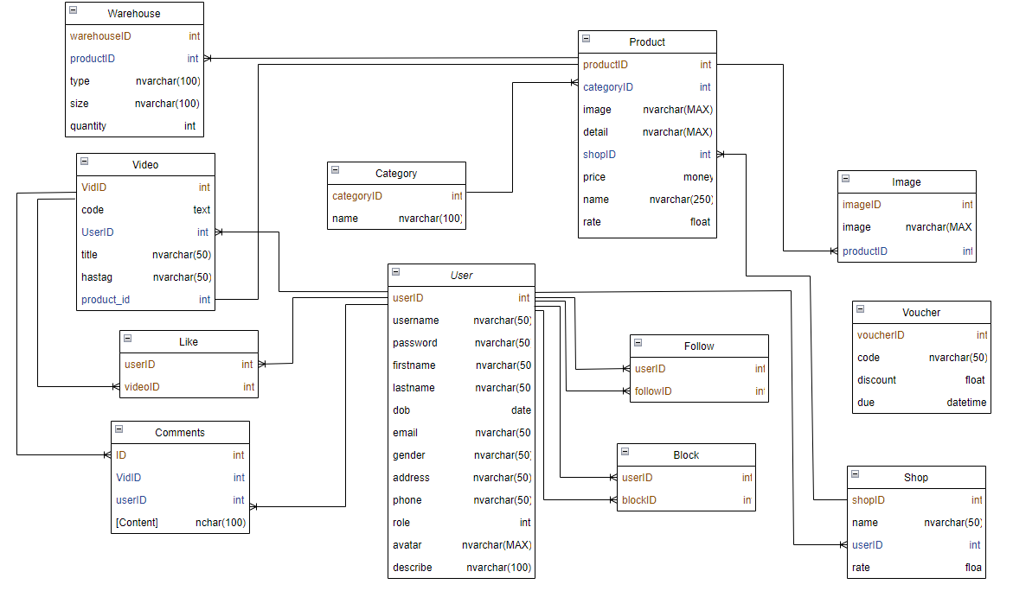

#### **b. Table Descriptions**

| **No** | **Table** | **Description** |
| --- | --- | --- |
| 01 | Product | Contain all information and detail of a product  - Primary keys: productID  - Foreign keys:   * categoryID (reference categoryID table Category) * shopID (reference shopID table Shop) |
| 02 | Category | Contain all category of product  - Primary keys: categoryID  - Foreign keys: none |
| 03 | Shop | Have information about name and rate of a shop  - Primary keys: shopID  - Foreign keys: userID (reference userID table User) |
| 04 | User | Contain all the personal information of account of a user  - Primary keys: userID  - Foreign keys: none |
| 05 | Comment | Contain all comment’s content of user and others detail about comment  - Primary keys: ID  - Foreign keys:   * VidID (reference VidID table Video) * userID (reference userID table User) |
| 06 | Video | Contain link of video and others information about it  - Primary keys: ID  - Foreign keys:   * VidID (reference VidID table Video) * userID (reference userID table User) |
| 07 | Image | Contain a list of sub images of a product  - Primary keys: imageID  - Foreign keys: productID (reference productID table Product) |
| 08 | Warehouse | Contain quantity of each kind of a product distinguished by type or size  - Primary keys: warehouseID  - Foreign keys: productID (reference productID table Product) |
| 09 | Like | Contain information about detail of like relation between user and video  - Primary keys:   * userID * videoID   - Foreign keys:   * userID (reference userID table User) * videoID (reference videoID table Video) |
| 10 | Follow | Contain information about detail of follow relation like between user and user  - Primary keys:   * userID * followID   - Foreign keys:   * userID (reference userID table User) * followID (reference userID table User) |
| 11 | Voucher | Contain information about a voucher like code and discount  - Primary keys: voucherID  - Foreign keys: None |
| 12 | Block | Contain information about detail of follow relation like between user and user  - Primary keys:   * userID * blockID   - Foreign keys:   * userID (reference userID table User) * blockID (reference userID table User) |

### **3.2 Code Packages**

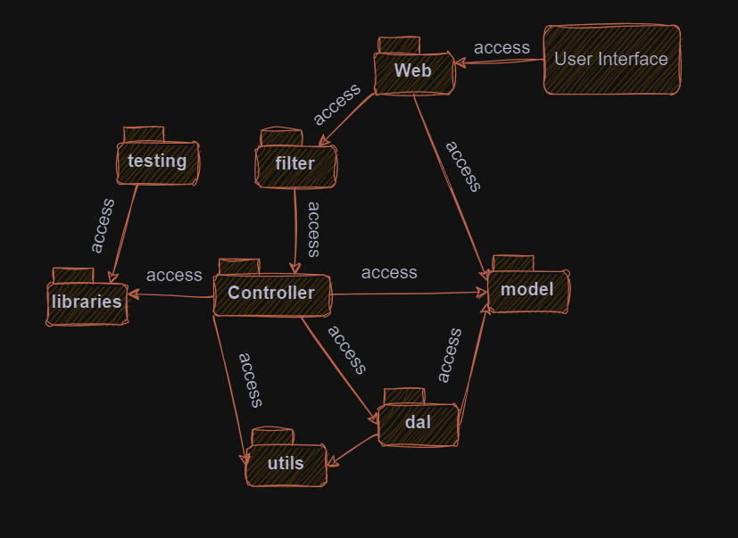

***Package descriptions***

| **No** | **Package** | **Description** |
| --- | --- | --- |
| 01 | web | The "web" package typically encompasses the front-end or user interface components of a web application. This package includes HTML, CSS, JavaScript, and other client-side technologies responsible for rendering and interacting with the application in a user's web browser. |
| 02 | dal | The "DAL" package is responsible for handling interactions with the application's data storage, typically a database. It abstracts the database operations, making it easier to perform actions like CRUD (Create, Read, Update, Delete) operations on the data. The DAL helps decouple the database logic from the rest of the application, enhancing maintainability and flexibility. |
| 03 | model | The "model" package is a part of the application's backend or server-side logic. It creates models containing information corresponding to tables in the database, it contains methods and initialization functions to create those models. |
| 04 | libraries | The "libraries" package includes third-party libraries or modules that are used to extend the functionality of the application. These libraries often consist of pre-built code or functions that can be integrated into the application to save time and effort in development. |
| 05 | util | The "utils" package contains utility or helper functions that are used throughout the application to perform common and repetitive tasks. These utilities make development more efficient by encapsulating commonly used code into reusable functions. |
| 06 | testing | The "testing" package contains code and scripts used for testing the application. It includes unit tests, integration tests, and other testing-related tools. Testing is essential for ensuring that the application functions as expected, and this package helps maintain the quality and reliability of the software. |
| 07 | filter | Filters are often used in web applications to intercept and process requests and responses. They play a crucial role in handling tasks like authentication, data validation, logging, and security. Filters are executed before the request reaches the application's main processing logic. |
| 08 | controller | The "controller" package is another crucial part of the application's backend. It is responsible for processing incoming requests, interacting with the model to retrieve or update data, and determining the appropriate response to send back to the client. Controllers serve as the middle layer that connects the user interface (web) with the data (model). |

# **II. Requirement Specifications**

| UC1 - Users List | |
| --- | --- |
| **User Case ID** | UC-1 |
| **User Case Name** | Users List |
| **Primary Actor** | Admin |
| **Description** | Show the paginated list of registered users, including users' id, full name, gender, email, mobile, role, and status. The admin can search by username and sort the list by various criteria. The admin can also ban or unban users and delete videos that violate the web's privacy rules. |
| **Pre-conditions** |  |
|  | The admin is logged in. |
| **Post-conditions** |  |
|  | The admin has viewed The list of Users and made necessary actions. |
| **Normal Flow** |  |
|  | 1. The admin accesses the "Users List" section. |
|  | 2. The admin browses the list of users. |
|  | 3. The admin can search for a specific user by username. |
|  | 4. The admin can sort the list by various criteria. |
|  | 5. The admin can take actions on individual users, such as banning, unbanning, and deleting videos. |
| **Alternative Flow** |  |
|  | #NAME? |
| **Exceptions** |  |
|  | N/a |
| **Priority** | High |
| **Frequency of use** | Low |
| **Business Rules** | Admins have the authority to manage user accounts. |
| **Other information** | N/A |
| UC2 - Restrict Seller | |
| **User Case ID** | UC-2 |
| **User Case Name** | Restrict Seller |
| **Primary Actor** | Admin |
| **Description** | If a seller's products receive poor feedback or many complaints, the admin checks and decides to suspend the seller if necessary. |
| **Pre-conditions** |  |
|  | The admin is logged in. |
|  | - A seller's account is under review. |
| **Post-conditions** |  |
|  | - The seller's privileges are restricted based on the admin's decision. |
| **Normal Flow** |  |
|  | 1. The admin logs in. |
|  | 2. The admin navigates to the seller's profile under review. |
|  | 3. The admin takes actions to restrict the seller's privileges. |
| **Alternative Flow** |  |
|  | N/a |
| **Exceptions** |  |
|  | N/a |
| **Priority** | High |
| **Frequency of use** | Low |
| **Business Rules** | Admins have the authority to manage seller accounts. |
| **Other information** | N/A |
| UC3 - Login | |
| **User Case ID** | UC-3 |
| **User Case Name** | Login |
| **Primary Actor** |  |
| **User** |  |
| **Admin** |  |
| **Shop Owner** |  |
| **Description** | This is a pop-up screen that allows the user to enter their username and password to log in. Users can also register for a new account or reset their password if they forget it. |
| **Pre-conditions** |  |
|  | The user has an account. |
|  | The user can access The system. |
| **Post-conditions** |  |
|  | The user is logged into The system. |
| **Normal Flow** |  |
|  | 1. The user accesses the login page. |
|  | 2. The user enters their username and password. |
|  | 3. The user clicks the login button. |
|  | 4. The system verifies the login information. |
|  | 5. If the login information is valid, the user is logged in. |
| **Alternative Flow** |  |
|  | If The login information is not valid, The system displays an error message and requests The user to try again. |
|  | Users can request a password reset If they forget their password. |
| **Exceptions** |  |
|  | - E1 - Username does not eist The system displays an error message "Username does not eist." |
|  | - E2 - Incorrect password The system displays an error message "Incorrect password." |
|  | E3 - Username or password is empty The system prompts Users to fill in both Username and password. |
| **Priority** | High |
| **Frequency of use** | High |
| **Business Rules** | Users must provide valid login information to access their accounts. |
| **Other information** | N/A |
| UC4 - Register | |
| **User Case ID** | UC-4 |
| **User Case Name** | Register |
| **Primary Actor** | Guest |
| **Description** | Users can register themselves to the system by providing personal information. They must verify their email before accessing the system. |
| **Pre-conditions** |  |
|  | The user is not already registered. |
| **Post-conditions** |  |
|  | The user has successfully registered and verified their email. |
| **Normal Flow** |  |
|  | 1. The user accesses the registration page. |
|  | 2. The user provides their first name, last name, username, email, phone number, date of birth, password, address, and gender. |
|  | 3. The user selects their role as a user or seller. |
|  | 4. The system checks the validity of the inputs and displays an error message if necessary. |
|  | 5. The user receives a verification email. |
|  | 6. The user clicks the verification link to activate their account. |
| **Alternative Flow** |  |
|  | N/a |
| **Exceptions** |  |
|  | E1 - Invalid input The system displays an error message If any input is invalid. |
| **Priority** | High |
| **Frequency of use** | Moderate |
| **Business Rules** | Users must verify their email before accessing the system. |
| **Other information** | N/A |
| UC5 - Reset Password | |
| **User Case ID** | UC-5 |
| **User Case Name** | Reset Password |
| **Primary Actor** | Guest |
| **Description** | Users can reset their password by providing their username. The new password is sent to the user's email. |
| **Pre-conditions** |  |
|  | The user has an account. |
| **Post-conditions** |  |
|  | - The user's password is successfully reset. |
| **Normal Flow** |  |
|  | 1. The user provides their username to initiate the password reset process. |
|  | 2. The system sends a new password to the user's email. |
|  | 3. The user's password in the system is updated to the new password. |
| **Alternative Flow** |  |
|  | N/a |
| **Exceptions** |  |
|  | N/a |
| **Priority** | Moderate |
| **Frequency of use** | Moderate |
| **Business Rules** | Users can reset their password if they forget it. |
| **Other information** | N/A |
| UC6 - Change Password | |
| **User Case ID** | UC-6 |
| **User Case Name** | Change Password |
| **Primary Actor** |  |
| **User** |  |
| **Admin** |  |
| **Shop Owner** |  |
| **Description** | Users can change their password by providing their current password and a new password. |
| **Pre-conditions** |  |
|  | The user is logged in. |
| **Post-conditions** |  |
|  | - The user's password is successfully changed. |
| **Normal Flow** |  |
|  | 1. The user accesses the password change page. |
|  | 2. The user provides their current password and a new password (twice). |
|  | 3. The system verifies the current password and updates the user's password to the new one. |
| **Alternative Flow** |  |
|  | N/a |
| **Exceptions** |  |
|  | N/a |
| **Priority** | Moderate |
| **Frequency of use** | Moderate |
| **Business Rules** | Users can change their password for security reasons. |
| **Other information** | N/A |
| UC7 - User Login with google | |
| **User Case ID** | UC-7 |
| **User Case Name** | User Login With Google |
| **Primary Actor** | Guest |
| **Description** | Users can log in or register with their Google account. User information such as first name, last name, avatar, and email is automatically retrieved from Google. |
| **Pre-conditions** |  |
|  | Users have a Google account. |
| **Post-conditions** |  |
|  | Users are logged in or registered with their Google account. |
| **Normal Flow** |  |
|  | 1. Users choose the option to log in or register with Google. |
|  | 2. Users are redirected |
|  |  |
|  | to the Google login page. |
|  | 3. Users log in with their Google credentials. |
|  | 4. The system retrieves user information from Google. |
|  | 5. Users are logged in or registered with their Google account. |
| **Alternative Flow** |  |
|  | N/a |
| **Exceptions** |  |
|  | N/a |
| **Priority** | Moderate |
| **Frequency of use** | Moderate |
| **Business Rules** | Users can log in or register with Google for convenience. |
| **Other information** | N/A |
| UC8 - Shop Page | |
| **User Case ID** | UC-8 |
| **User Case Name** | Shop Page |
| **Primary Actor** | Guest,User,Admin,Shop-Owner |
| **Description** | Displays various content on the shop page, including sliders, recent products, featured products, and the latest posts. Users can interact with the displayed content. |
| **Pre-conditions** |  |
|  | Users have access to The shop page. |
| **Post-conditions** |  |
|  | Users have viewed The shop page and interacted with The content. |
| **Normal Flow** |  |
|  | 1. Users access the shop page. |
|  | 2. Users view sliders with images and titles. |
|  | 3. Users view recent products with thumbnail, title, rating, and price. |
|  | 4. Users view featured products. |
|  | 5. Users can click on a product to view its details. |
|  | 6. Users view a slider with the latest posts, sale information, and static contacts/links. |
|  | 7. Users can navigate through all categories. |
| **Alternative Flow** |  |
|  | N/a |
| **Exceptions** |  |
|  | N/a |
| **Priority** | Moderate |
| **Frequency of use** | High |
| **Business Rules** | Users can view and interact with shop page content. |
| **Other information** | N/A |
| UC9 - Products List | |
| **User Case ID** | UC-9 |
| **User Case Name** | Products List |
| **Primary Actor** | Guest,User,Admin,Shop-Owner |
| **Description** | Shows a paginated list of products with sorting, searching, and filtering options. Users can click on products to view details and access social media links in the footer. |
| **Pre-conditions** |  |
|  | Users have access to The products list page. |
| **Post-conditions** |  |
|  | Users have viewed The list of products and interacted with The content. |
| **Normal Flow** |  |
|  | 1. Users access the products list page. |
|  | 2. Users view the paginated list of products, including thumbnails, titles, prices, and shops. |
|  | 3. Users can click on a product to view its details. |
|  | 4. Users have access to the product search bo, categories, price and rating filters, and a reset option. |
|  | 5. Users can view links to the company's social media in the footer. |
|  | 6. Users can navigate through the paging options. |
| **Alternative Flow** |  |
|  | N/a |
| **Exceptions** |  |
|  | N/a |
| **Priority** | Moderate |
| **Frequency of use** | High |
| **Business Rules** | Users can view and interact with the products list. |
| **Other information** | N/A |
| UC10 - Product Details | |
| **User Case ID** | UC-10 |
| **User Case Name** | Product Details |
| **Primary Actor** | Guest,User,Admin,Shop-Owner |
| **Description** | Shows detailed product information, including title, category, slider images, price, and product details. Users can select size and type, change the quantity, and add the product to the cart. |
| **Pre-conditions** |  |
|  | Users have access to The product details page. |
| **Post-conditions** |  |
|  | Users have viewed The product details and may have added The product to The cart. |
| **Normal Flow** |  |
|  | 1. Users access the product details page. |
|  | 2. Users view product details, including title, category, slider images, price, and product details. |
|  | 3. Users can choose size and type and input the quantity they want. |
|  | 4. Users can add the product to the cart. |
|  | 5. Users can view links to the company's social media in the footer. |
| **Alternative Flow** |  |
|  | N/a |
| **Exceptions** |  |
|  | N/a |
| **Priority** | Moderate |
| **Frequency of use** | High |
| **Business Rules** | Users can view and interact with product details. |
| **Other information** | N/A |
| UC11 - Hashtag | |
| **User Case ID** | UC-11 |
| **User Case Name** | Hashtag |
| **Primary Actor** | Guest,User,Admin,Shop-Owner |
| **Description** | Users can add hashtags to their videos and display them in the video title. Users can also click on hashtags to view a list of videos with the same hashtag. |
| **Pre-conditions** |  |
|  | Users have access to The hashtag feature. |
| **Post-conditions** |  |
|  | Users have added hashtags to their videos and may have viewed videos with The same hashtags. |
| **Normal Flow** |  |
|  | 1. Users add hashtags to their videos and display them in the video title. |
|  | 2. Users can click on hashtags to view a list of videos with the same hashtag. |
|  | 3. Each hashtag has its viewing hours and likes, affecting the video's trend. |
| **Alternative Flow** |  |
|  | N/a |
| **Exceptions** |  |
|  | N/a |
| **Priority** | Moderate |
| **Frequency of use** | Moderate |
| **Business Rules** | Users can use hashtags to categorize their videos. |
| **Other information** | N/A |
| UC12 - Media tab | |
| **User Case ID** | UC-12 |
| **User Case Name** | Media tab |
| **Primary Actor** | Guest,User,Admin,Shop-Owner |
| **Description** | Displays short clips and ads uploaded by users or shop owners. Users can interact with the content, view details, like videos, and follow other users. |
| **Pre-conditions** |  |
|  | Users have access to The media tab. |
| **Post-conditions** |  |
|  | Users have viewed media content and may have interacted with it. |
| **Normal Flow** |  |
|  | 1. Users access the media tab. |
|  | 2. Users view short clips and ads with names, avatars, descriptions, like counts, and hashtags. |
|  | 3. Users can click on the comment icon to view comments or click on avatars/names to view profiles. |
|  | 4. Users can like videos, and the like count increases. |
|  | 5. Users can follow other users. |
| **Alternative Flow** |  |
|  | N/a |
| **Exceptions** |  |
|  | N/a |
| **Priority** | Moderate |
| **Frequency of use** | High |
| **Business Rules** | Users can view and interact with media content. |
| **Other information** | N/A |
| UC13 - View Other Profile | |
| **User Case ID:** | UC-13 |
| **User Case Name:** | View Other Profile |
| **Primary Actor:** | Guest,User,Admin,Shop-Owner |
| **Description:** | Displays the profile of another user, including their name, username, uploaded videos, the number of followers, and following. Users can follow and block the displayed user. |
| **Pre-conditions:** |  |
|  | Users have access to view other profiles. |
| **Post-conditions:** |  |
|  | - Users have viewed another user's profile and may have followed or blocked the user. |
| **Normal Flow:** |  |
|  | 1. Users access the profile of another user. |
|  | 2. Users view the information of the displayed user, including their name, username, uploaded videos, number of followers, and following. |
|  | 3. Users can follow or block the displayed user. |
| **Alternative Flow:** |  |
|  | N/a |
| **Eceptions:** |  |
|  | N/a |
| **Priority:** | Moderate |
| **Frequency of use:** | Moderate |
| **Business Rules:** | Users can view and interact with other users' profiles. |
| **Other information:** | N/A |
| UC14 - MKT Dashboard | |
| **User Case ID:** | UC-14 |
| **User Case Name:** | MKT Dashboard |
| **Primary Actor:** | Shop Owner |
| **Description:** | Displays statistics of products, customers, feedback, and the trend of new customers by day for the last 7 days. The start and end dates can be adjusted. |
| **Pre-conditions:** |  |
|  | shop owners have access to The MKT Dashboard. |
| **Post-conditions:** |  |
|  | shop owners have viewed marketing statistics. |
| **Normal Flow:** |  |
|  | 1. Shop owners access the MKT Dashboard. |
|  | 2. Shop owners view marketing statistics |
|  |  |
|  | , including data on products, customers, feedback, and trends. |
|  | 3. Shop owners can adjust the start and end dates to view specific time periods. |
| **Alternative Flow:** |  |
|  | N/a |
| **Eceptions:** |  |
|  | N/a |
| **Priority:** | High |
| **Frequency of use:** | Moderate |
| **Business Rules:** | Shop owners can view marketing statistics. |
| **Other information:** | N/A |
| UC15 - Shop Products List | |
| **User Case ID:** | UC-15 |
| **User Case Name:** | Shop Products List |
| **Primary Actor:** | Shop Owner |
| **Description:** | Displays a paginated list of products belonging to a shop, including products' IDs, thumbnails, titles, and categories. Shop owners can view and edit the products, as well as add new products or delete eisting ones. |
| **Pre-conditions:** |  |
|  | shop owners have access to The shop products list. |
| **Post-conditions:** |  |
|  | shop owners have viewed, edited, and managed their products. |
| **Normal Flow:** |  |
|  | 1. Shop owners access the shop products list. |
|  | 2. Shop owners view the paginated list of products, including product details. |
|  | 3. Shop owners can choose to view, edit, add new products, or delete eisting products. |
| **Alternative Flow:** |  |
|  | N/a |
| **Eceptions:** |  |
|  | N/a |
| **Priority:** | High |
| **Frequency of use:** | Moderate |
| **Business Rules:** | Shop owners can view and manage their products. |
| **Other information:** | N/A |
| UC16 - Shop Product Details | |
| **User Case ID:** | UC-16 |
| **User Case Name:** | Shop Product Details |
| **Primary Actor:** | Shop Owner |
| **Description:** | Shows detailed product information, including thumbnails, categories, titles, brief information, attached images, descriptions, quantities, and prices. Shop owners can input, view, or edit this information and add a list of product images. |
| **Pre-conditions:** |  |
|  | shop owners have access to The shop product details. |
| **Post-conditions:** |  |
|  | shop owners have viewed, input, or edited product details. |
| **Normal Flow:** |  |
|  | 1. Shop owners access the shop product details. |
|  | 2. Shop owners view detailed product information, including images, categories, titles, descriptions, quantities, and prices. |
|  | 3. Shop owners can input, view, or edit this information and add a list of product images. |
| **Alternative Flow:** |  |
|  | N/a |
| **Eceptions:** |  |
|  | N/a |
| **Priority:** | High |
| **Frequency of use:** | Moderate |
| **Business Rules:** | Shop owners can view and manage product details. |
| **Other information:** | N/A |
| UC17 - Shop List | |
| **User Case ID:** | UC-17 |
| **User Case Name:** | Shop List |
| **Primary Actor:** | Shop Owner |
| **Description:** | Displays a list of all shops owned by the user, including shop names and ratings. Shop owners can add new shops with name attributes, edit eisting shops, or delete shops. |
| **Pre-conditions:** |  |
|  | shop owners have access to The shop list. |
| **Post-conditions:** |  |
|  | shop owners have viewed and managed their shops. |
| **Normal Flow:** |  |
|  | 1. Shop owners access the shop list. |
|  | 2. Shop owners view a list of their shops, including shop names and ratings. |
|  | 3. Shop owners can add new shops, edit eisting shops, or delete shops. |
| **Alternative Flow:** |  |
|  | N/a |
| **Eceptions:** |  |
|  | N/a |
| **Priority:** | High |
| **Frequency of use:** | Low |
| **Business Rules:** | Shop owners can view and manage their shops. |
| **Other information:** | N/A |
| UC18 - Feedbacks List | |
| **User Case ID:** | UC-18 |
| **User Case Name:** | Feedbacks List |
| **Primary Actor:** | Shop Owner |
| **Description:** | Displays a list of feedbacks paginatedly, including contact full names, product names, rated stars, and statuses. Shop owners can filter feedbacks, search by full name or feedback content, and view or change feedback statuses. |
| **Pre-conditions:** |  |
|  | shop owners have access to The feedbacks list. |
| **Post-conditions:** |  |
|  | shop owners have viewed and managed feedbacks. |
| **Normal Flow:** |  |
|  | 1. Shop owners access the feedbacks list. |
|  | 2. Shop owners view a paginated list of feedbacks, including feedback details. |
|  | 3. Shop owners can filter feedbacks, search by full name or feedback content, and view or change feedback statuses. |
| **Alternative Flow:** |  |
|  | N/a |
| **Eceptions:** |  |
|  | N/a |
| **Priority:** | High |
| **Frequency of use:** | Moderate |
| **Business Rules:** | Shop owners can view and manage feedbacks related to their products. |
| **Other information:** | N/A |
| UC19 - Sale Dashboard | |
| **User Case ID:** | UC-19 |
| **User Case Name:** | Sale Dashboard |
| **Primary Actor:** | Shop Owner |
| **Description:** | Displays the trend of success/total orders and revenue trends by day for the last 7 days, for all orders or specific sale persons. Start date, end date, sale, and order status can be adjustable. |
| **Pre-conditions:** |  |
|  | shop owners have access to The sale Dashboard. |
| **Post-conditions:** |  |
|  | shop owners have viewed and analyzed sale data. |
| **Normal Flow:** |  |
|  | 1. Shop owners access the sale dashboard. |
|  | 2. Shop owners view trends in success/total orders and revenue by day for the last 7 days. |
|  | 3. Shop owners can adjust start dates, end dates, salespersons, and order statuses for customized views. |
| **Alternative Flow:** |  |
|  | N/a |
| **Eceptions:** |  |
|  | N/a |
| **Priority:** | High |
| **Frequency of use:** | Moderate |
| **Business Rules:** | Shop owners can view and analyze sale data. |
| **Other information:** | N/A |
| UC20 - Orders List | |
| **User Case ID:** | UC-20 |
| **User Case Name:** | Orders List |
| **Primary Actor:** | Shop Owner |
| **Description:** | Displays a list of orders paginatedly, including order details such as ID, order date, customer name, products, type, size, quantity, total cost, and status. Shop owners can filter orders, search orders by ID or customer name, and change the status of orders. |
| **Pre-conditions:** |  |
|  | shop owners have access to The orders list. |
| **Post-conditions:** |  |
|  | shop owners have viewed and managed orders. |
| **Normal Flow:** |  |
|  | 1. Shop owners access the orders list. |
|  | 2. Shop owners view a paginated list of orders, including order details. |
|  | 3. Shop owners can filter orders, search by order ID or customer name, and change the status of orders. |
| **Alternative Flow:** |  |
|  | N/a |
| **Eceptions:** |  |
|  | N/a |
| **Priority:** | High |
| **Frequency of use:** | Moderate |
| **Business Rules:** | Shop owners can view and manage orders related to their shop. |
| **Other information:** | N/A |
| UC21 - Order Details | |
| **User Case ID:** | UC-21 |
| **User Case Name:** | Order Details |
| **Primary Actor:** | Shop Owner |
| **Description:** | Displays the details of a specific order, including basic order information, receiver information, and a list of ordered products. Sale managers and assigned salespersons can change the order status and add sale notes. |
| **Pre-conditions:** |  |
|  | shop owners have access to The order details. |
| **Post-conditions:** |  |
|  | shop owners have viewed order details and may have changed The order status. |
| **Normal Flow:** |  |
|  | 1. Shop owners access the order details. |
|  | 2. Shop owners view the order's basic information, receiver information, and a list of ordered products. |
|  | 3. Sale managers and assigned salespersons can change the order status and add sale notes. |
| **Alternative Flow:** |  |
|  | N/a |
| **Eceptions:** |  |
|  | N/a |
| **Priority:** | High |
| **Frequency of use:** | Moderate |
| **Business Rules:** | Shop owners and sales managers can view and manage order details. |
| **Other information:** | N/A |
| UC22 - Shop-Owner Dashboard | |
| **User Case ID:** | UC-22 |
| **User Case Name:** | Shop-Owner Dashboard |
| **Primary Actor:** | Shop Owner |
| **Description:** | Displays statistics of new orders (success, canceled, submitted), revenues (total, by product categories), customers (newly registered, newly bought), feedbacks (average star: total, by product categories), and the trend of order counts (success, all) by day for the last 7 days. The start date and end date can be adjusted. |
| **Pre-conditions:** |  |
|  | shop owners have access to The shop-owner Dashboard. |
| **Post-conditions:** |  |
|  | shop owners have viewed and analyzed shop-owner data. |
| **Normal Flow:** |  |
|  | 1. Shop owners access the shop-owner dashboard. |
|  | 2. Shop owners view statistics on new orders, revenues, customers, feedbacks, and the trend of order counts. |
|  | 3. Shop owners can adjust start dates and end dates for customized views. |
| **Alternative Flow:** |  |
|  | N/a |
| **Eceptions:** |  |
|  | N/a |
| **Priority:** | High |
| **Frequency of use:** | Moderate |
| **Business Rules:** | Shop owners can view and analyze shop-owner data. |
| **Other information:** | N/A |
| UC23 - Add Coupon | |
| **User Case ID:** | UC-23 |
| **User Case Name:** | Add Coupon |
| **Primary Actor:** | Shop Owner |
| **Description:** | Allows shop owners to provide coupons to potential buyers or during events. Users can enter a coupon code to receive a discount from their order. |
| **Pre-conditions:** |  |
|  | shop owners have access to The add coupon feature. |
| **Post-conditions:** |  |
|  | shop owners have created and managed coupons. |
| **Normal Flow:** |  |
|  | 1. Shop owners access the add coupon feature. |
|  | 2. Shop owners can create coupons with specific discount codes. |
|  | 3. Users can enter a coupon code to receive discounts when making a purchase. |
| **Alternative Flow:** |  |
|  | N/a |
| **Eceptions:** |  |
|  | N/a |
| **Priority:** | Moderate |
| **Frequency of use:** | Low |
| **Business Rules:** | Shop owners can create and manage coupons for discounts. |
| **Other information:** | N/A |
| UC24 - Upload Video with Product Link | |
| **User Case ID:** | UC-24 |
| **User Case Name:** | Upload Video with Product Link |
| **Primary Actor:** | Shop Owner |
| **Description:** | Shop owners can upload videos and add product links to the videos they upload. |
| **Pre-conditions:** |  |
|  | shop owners have access to The upload video with product link feature. |
| **Post-conditions:** |  |
|  | shop owners have uploaded videos with product links. |
| **Normal Flow:** |  |
|  | 1. Shop owners access the upload video with product link feature. |
|  | 2. Shop owners upload videos and have the option to add product links to the videos. |
| **Alternative Flow:** |  |
|  | N/a |
| **Eceptions:** |  |
|  | N/a |
| **Priority:** | High |
| **Frequency of use:** | Moderate |
| **Business Rules:** | Shop owners can upload videos with product links. |
| **Other information:** | N/A |
| UC25 - Cart Details | |
| **User Case ID:** | UC-25 |
| **User Case Name:** | Cart Details |
| **Primary Actor:** | User,Admin,Shop Owner |
| **Description:** | Displays the cart details with a list of the user's chosen products, total order price, shipping options, and a bo to enter a voucher code for a discount. Users can manage the cart's content and proceed to checkout. |
| **Pre-conditions:** |  |
|  | Users have added products to their cart. |
| **Post-conditions:** |  |
|  | - Users have viewed and managed the cart's content and may proceed to checkout. |
| **Normal Flow:** |  |
|  | 1. Users access the cart details. |
|  | 2. Users view the list of their chosen products with titles, prices, types, sizes, quantities, and total costs. |
|  | 3. Users can manage the cart content by changing quantities or removing products. |
|  | 4. Users can choose a shipping method. |
|  | 5. Users can enter a voucher code for a discount. |
|  | 6. Users can return to the product list or |
| UC26 - Cart Contact | |
| **User Case ID:** | UC-26 |
| **User Case Name:** | Cart Contact |
| **Primary Actor:** | User,Admin,Shop Owner |
| **Description:** | Displays the list of user's chosen products with product details (title, price, type, size, quantity, total cost) and the receiver's information (including full name, mobile, address, and notes). Provides product search, product categories, the latest products, and static contacts/links. Users can edit or input receiver information. |
| **Pre-conditions:** |  |
|  | Users have added products to their cart. |
| **Post-conditions:** |  |
|  | - Users have reviewed and edited the cart's content and inputted or edited receiver information. |
| **Normal Flow:** |  |
|  | 1. Users access the cart contact details. |
|  | 2. Users view the list of chosen products with product details. |
|  | 3. Users see the total order price and the receiver information section. |
|  | 4. Users can edit or input receiver information, including full name, mobile, address, and notes. |
|  | 5. Users can continue shopping by returning to the product list or proceed to checkout. |
| **Alternative Flow:** |  |
|  | N/a |
| **Eceptions:** |  |
|  | N/a |
| **Priority:** | Moderate |
| **Frequency of use:** | Moderate |
| **Business Rules:** | Users can review and edit the cart's content and input or edit receiver information. |
| **Other information:** | N/A |
| UC27 - Cart Completion | |
| **User Case ID:** | UC-27 |
| **User Case Name:** | Cart Completion |
| **Primary Actor:** | User,Admin,Shop Owner |
| **Description:** | This page shows cart completion notes about order details, which includes: |
|  | - Changing the order status to "Pending." |
|  | - Updating the product's available quantities. |
|  | - Sending an order confirmation and order details to the customer's email. |
|  | Displaying order information on The page. |
| **Pre-conditions:** |  |
|  | Users have edited The cart content and provided receiver information. |
| **Post-conditions:** |  |
|  | The order has been placed, and Users have received order confirmation and details. |
| **Normal Flow:** |  |
|  | 1. Users access the cart completion page. |
|  | 2. The system: |
|  | - Changes the order status to "Pending." |
|  | - Updates the product's available quantities. |
|  | - Sends an order confirmation and order details to the customer's email. |
|  | - Displays order information on the page. |
|  | 3. Users can see the confirmation and details of the placed order. |
| **Alternative Flow:** |  |
|  | N/a |
| **Eceptions:** |  |
|  | N/a |
| **Priority:** | High |
| **Frequency of use:** | Low |
| **Business Rules:** | Users complete the order, and the system updates relevant order details. |
| **Other information:** | N/A |
| UC28 - Feedback | |
| **User Case ID:** | UC-28 |
| **User Case Name:** | Feedback |
| **Primary Actor:** | Admin,Shop Owner |
| **Description:** | Allows users to provide feedback on the bought products. Users can submit feedback via the website, and they also receive a confirmation email with instructions for providing feedback on each received product. |
| **Pre-conditions:** |  |
|  | Users have placed an order and received products. |
| **Post-conditions:** |  |
|  | Users have provided feedback on The bought products, either via The website or email. |
| **Normal Flow:** |  |
|  | 1. Users access the feedback page. |
|  | 2. Users can provide feedback on each of the received products or give general feedback via the website. |
|  | 3. Users receive a confirmation email with instructions for providing feedback on each received product. |
| **Alternative Flow:** |  |
|  | N/a |
| **Eceptions:** |  |
|  | N/a |
| **Priority:** | High |
| **Frequency of use:** | Low |
| **Business Rules:** | Users can provide feedback on the bought products via the website and email. |
| **Other information:** | N/A |
| UC29 - My Orders | |
| **User Case ID:** | UC-29 |
| **User Case Name:** | My Orders |
| **Primary Actor:** | Admin,Shop Owner |
| **User:** |  |
| **Admin:** |  |
| **Shop Owner:** |  |
| **Description:** | Displays a list of the user's orders, paginated by the status of the order. Users can choose each status to see all orders in that status. Each order displays the name, type, size, total price, quantity, and small image. |
| **Pre-conditions:** |  |
|  | Users have placed orders. |
| **Post-conditions:** |  |
|  | Users have viewed their order history and can access order details. |
| **Normal Flow:** |  |
|  | 1. Users access the "My Orders" page. |
|  | 2. Users see a list of their orders, paginated by order status. |
|  | 3. Users can select a specific status to view orders in that status. |
|  | 4. Each order displays order details such as name, type, size, total price, quantity, and a small image. |
| **Alternative Flow:** |  |
|  | N/a |
| **Eceptions:** |  |
|  | N/a |
| **Priority:** | Moderate |
| **Frequency of use:** | Moderate |
| **Business Rules:** | Users can view their order history and access order details. |
| **Other information:** | N/A |
| UC30 - Order Information | |
| **User Case ID:** | UC-30 |
| **User Case Name:** | Order Information |
| **Primary Actor:** | User |
| **User:** |  |
| **Admin:** |  |
| **Shop Owner:** |  |
| **Description:** | Displays the details of a specific order, including the order ID, order date, total cost, status, and receiver information. It also includes a list of ordered products with details and links/buttons for re-buying or providing feedback. |
| **Pre-conditions:** |  |
|  | Users have accessed a specific order from their order history. |
| **Post-conditions:** |  |
|  | Users have viewed The details of a specific order and can re-buy or provide feedback. |
| **Normal Flow:** |  |
|  | 1. Users access a specific order from their order history. |
|  | 2. Users see the details of the selected order, including the order ID, order date, total cost, status, and receiver information. |
|  | 3. A list of ordered products is displayed, with details such as thumbnail, name, category, unit price, quantity, total cost, and links/buttons for re-buying or providing feedback. |
| **Alternative Flow:** |  |
|  | N/a |
| **Eceptions:** |  |
|  | N/a |
| **Priority:** | Moderate |
| **Frequency of use:** | Low |
| **Business Rules:** | Users can view the details of a specific order and can re-buy or provide feedback. |
| **Other information:** | N/A |
| UC31 - Edit Profile | |
| **User Case ID:** | UC-31 |
| **User Case Name:** | Edit Profile |
| **Primary Actor:** | User |
| **User:** |  |
| **Admin:** |  |
| **Shop Owner:** |  |
| **Description:** | This is a screen that allows users to edit their profile information, including the registered ones and the avatar image. Users can change their roles from a user to a seller, which will redirect them to the "Add Shop" screen. |
| **Pre-conditions:** |  |
|  | Users have access to The edit profile feature. |
| **Post-conditions:** |  |
|  | Users have successfully edited their profile information. |
| **Normal Flow:** |  |
|  | 1. Users access the edit profile screen. |
|  | 2. Users can edit their profile information, including registered details and the avatar image. |
|  | 3. Users can change their roles from a user to a seller, which will redirect them to the "Add Shop" screen. |
| **Alternative Flow:** |  |
|  | N/a |
| **Eceptions:** |  |
|  | N/a |
| **Priority:** | Moderate |
| **Frequency of use:** | Low |
| **Business Rules:** | Users can edit their profile information and change their roles. |
| **Other information:** | N/A |
| UC32 - User Authorization | |
| **User Case ID:** | UC-32 |
| **User Case Name:** | User Authorization |
| **Primary Actor:** | User |
| **User:** |  |
| **Admin:** |  |
| **Shop Owner:** |  |
| **Description:** | This involves the implementation of an authorization mechanism in the system. It includes specifying the role of the logged-in user, his/her authorized page links (building the displayed menu items in the front end), and preventing unauthorized access via direct links. |
| **Pre-conditions:** |  |
|  | Users have logged in to The system. |
| **Post-conditions:** |  |
|  | Users have specified their roles and authorized page links in The system. |
| **Normal Flow:** |  |
|  | 1. Users log in to the system. |
|  | 2. Users specify their roles, and the system authorizes page links based on the role. |
|  | 3. Users see the menu items displayed according to their authorized pages. |
|  | 4. Unauthorized access to specific pages via direct links is prevented. |
| **Alternative Flow:** |  |
|  | N/a |
| **Eceptions:** |  |
|  | N/a |
| **Priority:** | High |
| **Frequency of use:** | Low |
| **Business Rules:** | Users specify their roles and authorized page links in the system, and unauthorized access is prevented. |
| **Other information:** | N/A |
| UC33 - Notification | |
| **User Case ID:** | UC-33 |
| **User Case Name:** | Notification |
| **Primary Actor:** | User |
| **User:** |  |
| **Admin:** |  |
| **Shop Owner:** |  |
| **Description:** | Users will receive notifications about discount codes, updated order status, and notifications from the system via email. |
| **Pre-conditions:** |  |
|  | Users have subscribed to receive notifications. |
| **Post-conditions:** |  |
|  | Users have received email notifications about relevant events. |
| **Normal Flow:** |  |
|  | 1. Users have subscribed to receive notifications. |
|  | 2. Users receive email notifications about events such as discount codes, updated order status, and other system notifications. |
| **Alternative Flow:** |  |
|  | N/a |
| **Eceptions:** |  |
|  | N/a |
| **Priority:** | High |
| **Frequency of use:** | Moderate |
| **Business Rules:** | Users receive email notifications about relevant events. |
| **Other information:** | N/A |
| UC34 - Follow User | |
| **User Case ID:** | UC-34 |
| **User Case Name:** | Follow User |
| **Primary Actor:** | User |
| **User:** |  |
| **Admin:** |  |
| **Shop Owner:** |  |
| **Description:** | Users can follow other users, increasing the number of their followers and their following. Videos of the person the user has just followed will appear more on the media tab. |
| **Pre-conditions:** |  |
|  | Users have access to The follow user feature. |
| **Post-conditions:** |  |
|  | Users have followed other users. |
| **Normal Flow:** |  |
|  | 1. Users access the follow user feature. |
|  | 2. Users choose to follow other users. |
|  | 3. The number of their followers and following is increased. |
|  | 4. Videos of the followed person will appear more frequently on the user's media tab. |
| **Alternative Flow:** |  |
|  | N/a |
| **Eceptions:** |  |
|  | N/a |
| **Priority:** | Moderate |
| **Frequency of use:** | Moderate |
| **Business Rules:** | Users can follow other users, increasing their follower and following counts. |
| **Other information:** | N/A |
| UC35 - Block User | |
| **User Case ID:** | UC-35 |
| **User Case Name:** | Block User |
| **Primary Actor:** | User |
| **User:** |  |
| **Admin:** |  |
| **Shop Owner:** |  |
| **Description:** | Users can block an account, preventing the blocked user's videos from appearing in the user's media tab. The blocked person's personal page will also be empty. |
| **Pre-conditions:** |  |
|  | Users have access to The block user feature. |
| **Post-conditions:** |  |
|  | - Users have successfully blocked another user, preventing their videos from appearing in the user's media tab. |
| **Normal Flow:** |  |
|  | 1. Users access the block user feature. |
|  | 2. Users choose to block another user's account. |
|  | 3. The blocked user's videos no longer appear in the user's media tab. |
|  | 4. The blocked person's personal page is empty and inaccessible to the user. |
| **Alternative Flow:** |  |
|  | N/a |
| **Eceptions:** |  |
|  | N/a |
| **Priority:** | Moderate |
| **Frequency of use:** | Low |
| **Business Rules:** | Users can block another user's account, preventing their videos from appearing in the user's media tab. |
| **Other information:** | N/A |
| UC36 - Report Seller | |
| **User Case ID:** | UC-36 |
|  |  |
|  |  |
| **User Case Name:** | Report Seller |
| **Primary Actor:** | User |
| **User:** |  |
| **Admin:** |  |
| **Shop Owner:** |  |
| **Description:** | This function will show the customer the report form if the customer BOUGHT the product. After submitting the form, it will be sent to the admin for review. |
| **Pre-conditions:** |  |
|  | Users have purchased a product and can access The report seller feature. |
| **Post-conditions:** |  |
|  | Users have submitted a report about a seller, and The report is sent to The admin for review. |
| **Normal Flow:** |  |
|  | 1. Users have purchased a product and can access the report seller feature. |
|  | 2. Users choose to report a seller. |
|  | 3. Users fill out the report form. |
|  | 4. Users submit the report form. |
|  | 5. The report is sent to the admin for review. |
| **Alternative Flow:** |  |
|  | N/a |
| **Eceptions:** |  |
|  | N/a |
| **Priority:** | Moderate |
| **Frequency of use:** | Low |
| **Business Rules:** | Users can report a seller, and the report is sent to the admin for review. |
| **Other information:** | N/A |
| UC37 - User Profile | |
| **User Case ID:** | UC-37 |
| **User Case Name:** | User Profile |
| **Primary Actor:** | User |
| **User:** |  |
| **Admin:** |  |
| **Shop Owner:** |  |
| **Description:** | Displays user profile information, including full name, email, phone, date of birth, address, age, bio, all uploaded videos of that user, and avatar. It also displays a list of followers, following, and a user-blocked list. |
| **Pre-conditions:** |  |
|  | - Users can access their own or another user's profile. |
| **Post-conditions:** |  |
|  | Users have viewed The profile of a specific user. |
| **Normal Flow:** |  |
|  | 1. Users access the user profile. |
|  | 2. Users see the user profile information, including full name, email, phone, date of birth, address, age, bio, all uploaded videos of that user, and avatar. |
|  | 3. Users can view a list of followers, following, and a user-blocked list. |
| **Alternative Flow:** |  |
|  | N/a |
| **Eceptions:** |  |
|  | N/a |
| **Priority:** | Moderate |
| **Frequency of use:** | Moderate |
| **Business Rules:** | Users can view the profile of a specific user, including their information and uploaded videos. |
| **Other information:** | N/A |
| UC38 - Upload Video | |
| **User Case ID:** | UC-38 |
| **User Case Name:** | Upload Video |
| **Primary Actor:** | User |
| **User:** |  |
| **Admin:** |  |
| **Shop Owner:** |  |
| **Description:** | Users can upload their videos to the platform, including inputting information such as title, video, and hashtags. If a shop owner uploads a video, they will have an option to add a product link to their video. |
| **Pre-conditions:** |  |
|  | Users have access to The upload video feature. |
| **Post-conditions:** |  |
|  | Users have successfully uploaded a video to The platform, including providing video information and, in The case of a shop owner, adding a product link. |
| **Normal Flow:** |  |
|  | 1. Users access the upload video feature. |
|  | 2. Users input video information, including title, video file, and hashtags. |
|  | 3. If the user is a shop owner, they have the option to add a product link to the video. |
|  | 4. Users successfully upload the video to the platform. |
| **Alternative Flow:** |  |
|  | N/a |
| **Eceptions:** |  |
|  | N/a |
| **Priority:** | High |
| **Frequency of use:** | Moderate |
| **Business Rules:** | Users can upload their videos to the platform and, in the case of shop owners, add a product link to their videos. |
| **Other information:** | N/A |
| UC39 - Video Manage | |
| **User Case ID:** | UC-39 |
| **User Case Name:** | Video Manage |
| **Primary Actor:** | User |
| **User:** |  |
| **Admin:** |  |
| **Shop Owner:** |  |
| **Description:** | Users can view the list of videos they have uploaded and manage them by editing or deleting the video. |
| **Pre-conditions:** |  |
|  | Users have access to The video manage feature and have uploaded videos. |
| **Post-conditions:** |  |
|  | Users have viewed and managed their uploaded videos by editing or deleting them. |
| **Normal Flow:** |  |
|  | 1. Users access the video manage feature. |
|  | 2. Users see a list of their uploaded videos. |
|  | 3. Users can choose to edit or delete a video from the list. |
|  | 4. Users successfully manage their uploaded videos. |
| **Alternative Flow:** |  |
|  | N/a |
| **Eceptions:** |  |
|  | N/a |
| **Priority:** | Moderate |
| **Frequency of use:** | Low |
| **Business Rules:** | Users can view and manage their uploaded videos by editing or deleting them. |
| **Other information:** | N/A |
| UC40 - Video Dashboard | |
| **User Case ID:** | UC-40 |
| **User Case Name:** | Video Dashboard |
| **Primary Actor:** | User |
| **User:** |  |
| **Admin:** |  |
| **Shop Owner:** |  |
| **Description:** | Users can view statistics on the number of views, likes, and comments in their videos. |
| **Pre-conditions:** |  |
|  | Users have access to The video dashboard feature and have uploaded videos. |
| **Post-conditions:** |  |
|  | Users have viewed statistics on The number of views, likes, and comments in their videos. |
| **Normal Flow:** |  |
|  | 1. Users access the video dashboard feature. |
|  | 2. Users see statistics on the number of views, likes, and comments in their uploaded videos. |
| **Alternative Flow:** |  |
|  | N/a |
| **Eceptions:** |  |
|  | N/a |
| **Priority:** | Moderate |
| **Frequency of use:** | Low |
| **Business Rules:** | Users can view statistics on the number of views, likes, and comments in their videos. |
| **Other information:** | N/A |
| UC41 - Messaging | |
| **User Case ID:** | UC-41 |
| **User Case Name:** | Messaging |
| **Primary Actor:** | User |
| **User:** |  |
| **Admin:** |  |
| **Shop Owner:** |  |
| **Description:** | Users can message each other, and the chat bo will be updated every time one person messages the other. Users can also message the shop owner. |
| **Pre-conditions:** |  |
|  | Users have access to The messaging feature. |
| **Post-conditions:** |  |
|  | Users have sent and received messages from others, and The chat bo is updated with The conversation. |
| **Normal Flow:** |  |
|  | 1. Users access the messaging feature. |
|  | 2. Users can send messages to other users, and the chat bo is updated every time a message is sent or received. |
|  | 3. Users can also message the shop owner. |
| **Alternative Flow:** |  |
|  | N/a |
| **Eceptions:** |  |
|  | N/a |
| **Priority:** | Moderate |
| **Frequency of use:** | Moderate |
| **Business Rules:** | Users can send and receive messages to/from other users and the shop owner. |
| **Other information:** | N/A |

# **III. Design Specifications**

## **1. Common Features**

### **1.1 User Login**

* **UC1 User Login**

#### **UI Design**

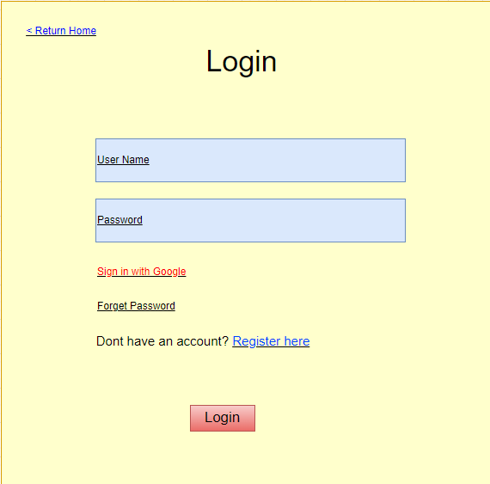

| **Field Name** | **Field Type** | **Description** |
| --- | --- | --- |
| **Username\*** | **Text Box** | **This is for user to input valid username for logging in** |
| **Password\*** | **Password Box** | **This is for user to input password for logging in** |
| **Sign in with Google** | **Hyperlink** | **Allow user to login with his/her Google account** |
| **Forget password** | **Hyperlink** | **User clicks to redirect to the Password Reset page for resetting his/her forgot password** |
| **Register** | **Button** | **User clicks to redirect to the User Register page for registering new user account to access the system** |
| **Login** | **Button** | **User clicks to authenticate him/herself into the system with provided email & password** |

#### **Database Access**

| **Table** | **CRUD** | **Description** |
| --- | --- | --- |
| **User** | **R** | **- Verify UserName & Password information**  **- Specify the authorizations of the logged-in user** |

***SQL Commands:***

**1/ Verify UserName & Password information**

**SELECT * from [User] where username=? and password=?**

**2/ Access Google Account (not yet registered)**

**insert into [dbo].[User]  
values(?,?,?,?,?,?,?,?,?,?,?,?)**

### **1.2 User Register**

* **UC2 User Register**

#### **UI Design**

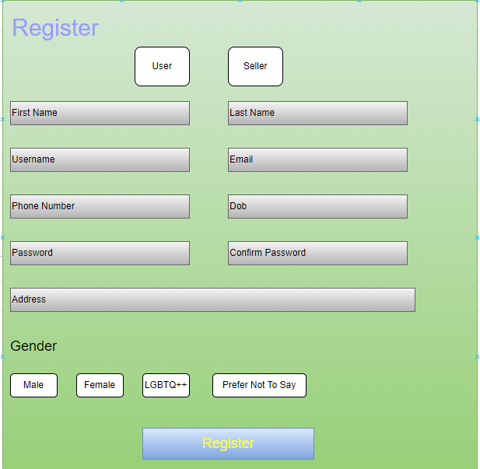

| **Field Name** | **Field Type** | **Description** |
| --- | --- | --- |
| **Role** | **Button** | **User selects the role that they wanted** |
| **First Name** | **Text Box** | **User enters their first name** |
| **Last Name** | **Text Box** | **User enters their last name** |
| **Username** | **Text Box** | **The user enters the username he wants to register** |
| **Email** | **Text Box** | **The user enters the email used to authenticate registration** |
| **Phone Number** | **Number Box** | **User enters phone number** |
| **Dob** | **Date Box** | **User enters date of birth** |
| **Password** | **Text Box** | **The user enters the password he wants to register** |
| **Confirm Password** | **Text Box** | **The user reconfirms the password he wants to register** |
| **Address** | **Text Box** | **User enters address** |
| **Gender** | **Radio Button** | **User selects gender** |
| **Register** | **Button** | **Go directly to the Verify OTP page to confirm if user info was clear** |

#### **Database Access**

| **Table** | **CRUD** | **Description** |
| --- | --- | --- |
| **User** | **C** | **Insert account registered** |

***SQL Commands:***

**1/ Add an account that has been successfully registered and authenticated to the database**

**insert into [dbo].[User]**

**VALUES (?,?,?,?,?,?,?,?,?,?,?,?)**

**2/ Check if username exists or not**

**select * from [User] where username=?**

### **1.3 Reset Password (Forget Password)**

* **UC3_Reset Password**

#### **UI Design**

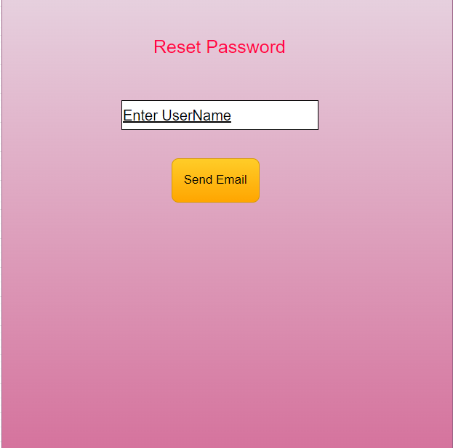

| **Field Name** | **Field Type** | **Description** |
| --- | --- | --- |
| **User Name** | **Text Box** | **User enter the username that he used** |
| **Send** | **Button** | **An message will bel send directly to the user email**  **with the new password key** |

#### **Database Access**

| **Table** | **CRUD** | **Description** |
| --- | --- | --- |
| **User** | **R**  **U** | **check if the username exist in the database**  **update a new password for the user** |

***SQL Commands:***

**1/ Check if username exists or not**

**select * from [User] where username=?**

**2/ Set new password for user**

**update [User] set password=? where username=?**

### **1.4 Change Password**

* **UC4_Change Password**

#### **UI Design**

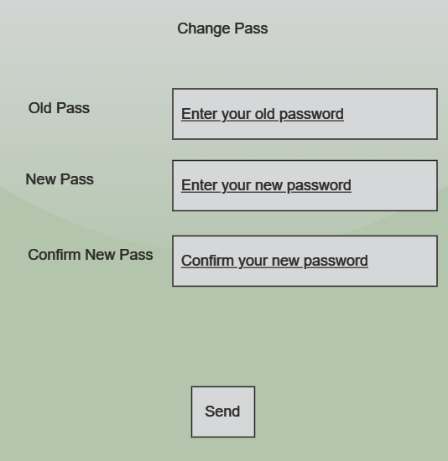

| **Field Name** | **Field Type** | **Description** |
| --- | --- | --- |
| **Old Password** | **Text Box** | **This is for user to input current password** |
| **New password** | **Text Box** | **This is for user to input new Password (Different from current password)** |
| **Confirm Password** | **Text Box** | **This is for user to input again new password** |
| **Send** | **Button** | **Save new password for user** |

#### **Database Access**

| **Table** | **CRUD** | **Description** |
| --- | --- | --- |
| **Account** | **R** | **Verify UserName & Password information** |

***SQL Commands:***

**1/ Set new password for user**

**update Account  
set [password] = ?  
where username = ?**

### **1.5 User Profile**

* **UC5 User Profile**

#### **UI Design**

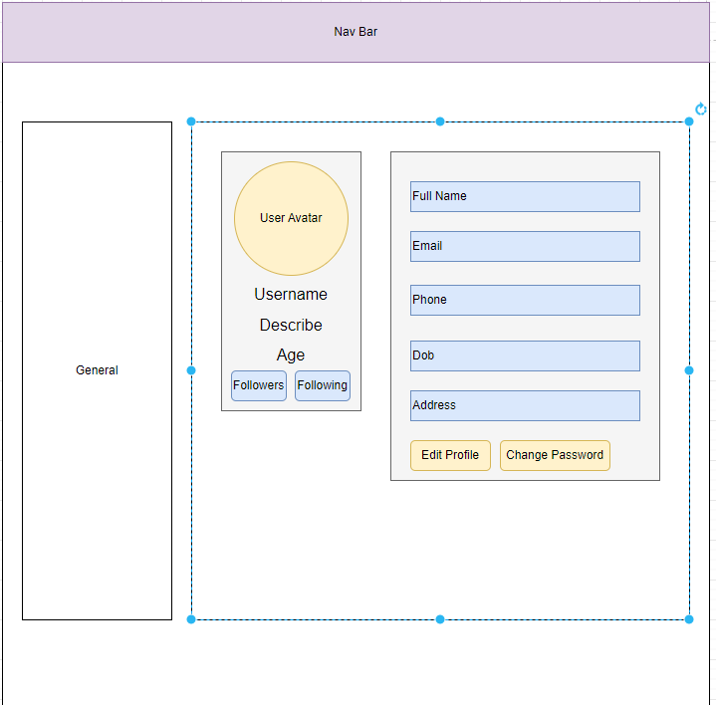

| **Field Name** | **Field Type** | **Description** |
| --- | --- | --- |
| **User Avatar** | **Text Box**  **(read only)** | **Show the user Avatar on the screen but user can not change the details on this page** |
| **User Name** | **Text Box**  **(read only)** | **Show the username but user can not change the details on this page** |
| **Describe** | **Text Box**  **(read only)** | **Show the description of the User. Mostly show “no bio yet.” for the new account** |
| **Age** | **Text Box**  **(read only)** | **Show the age of the User** |
| **User Full Name** | **Text Box**  **(read only)** | **Show the Full Name of the User but user can not change the details on this page** |
| **Email** | **Text Box**  **(read only)** | **Show the Email of the User but user can not change the details on this page** |
| **Phone** | **Text Box**  **(read only)** | **Show the Phone number of the User but user can not change the details on this page** |
| **Date Of Birth** | **Text Box**  **(read only)** | **Show the birth day of the User but user can not change the details on this page** |
| **Address** | **Text Box**  **(read only)** | **Show the address of the User but user can not change the details on this page** |
| **Follower** | **Button** | **Popup and Show the User how many followers they have** |
| **Following** | **Button** | **Popup and Show the User, whom they are following** |
| **Edit Profile** | **Button** | **Send directly to the Edit Profile Page** |
| **Change Password** | **Button** | **Send directly to the Change Password Page** |

#### **Database Access**

| **Table** | **CRUD** | **Description** |
| --- | --- | --- |
| **Account** | **R** | **Show User Personal Information** |
| **Follow** | **R** | **Show all of followers and following User** |

***SQL Commands:***

**1/ Show the personal information of user**

**SELECT * From User WHERE userID = ?**

**2/Show the followers, following number**

**Select u.* from [User] u, Follow f**

**where u.userID = f.userID**

**And f.followID = ?**

**Select u .* from [User] u, Follow f**

**where u.userID = f.followID**

**And f.userID = ?**

### **1.6 OTP Verify**

* **UC6 OTP Verify**

#### **UI Design**

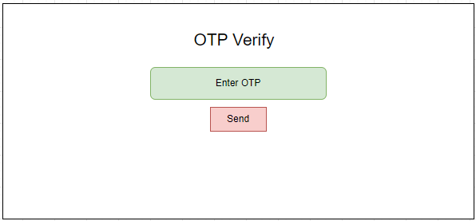

| **Field Name** | **Field Type** | **Description** |
| --- | --- | --- |
| **Enter OTP** | **Text Box** | **User type the OTP Code that was sent in the email** |
| **Send** | **Button** | **User clicks to check the OTP Code** |

#### **Database Access**

| **Table** | **CRUD** | **Description** |
| --- | --- | --- |
| **User** | **C** | **Insert account registered** |

***SQL Commands:***

**1/ Add an account that has been successfully registered and authenticated to the database**

**insert into [dbo].[User]**

**VALUES (?,?,?,?,?,?,?,?,?,?,?,?)**

#### 

## **2. Public Features**

### **2.1 Home Page**

* **UC8_Post List**

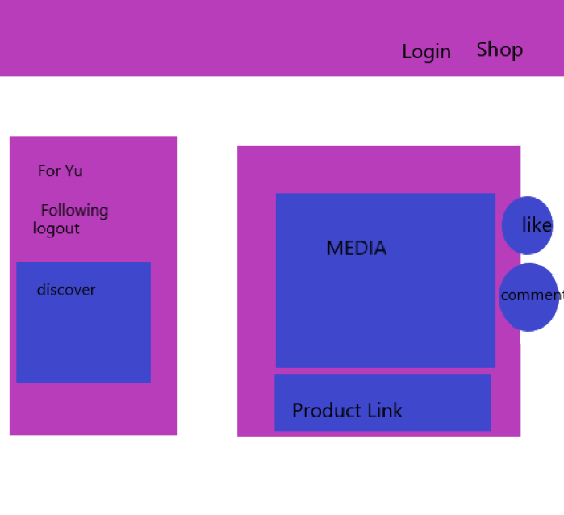

#### **UI Design**

| **Field Name** | **Field Type** | **Description** |
| --- | --- | --- |
| **Login** | **Button** | **The user click the button to forward to the user login page** |
| **Logo** | **Button** | **Click the logo to back to home page** |
| **Shop** | **Button** | **The user click the button to forward to the shop page** |
| **Video List** | **A list of video with name, hashtag, description, product** | **This section shows users the list of video** |
| **Profile** | **Button** | **The user click the button to forward to the channel/shop’s personal information** |
| **Product** | **Button** | **The user click the button to forward to the product in video** |
| **Upload** | **Button** | **Click the logo to upload a video** |

#### **Database Access**

| **Table** | **CRUD** | **Description** |
| --- | --- | --- |
| **Video** | **R** | **List all videos** |
| **Product** | **R** | **Display product in the video** |
| **User** | **R** | **Display user that uploaded the video** |

***SQL Commands:***

**1/ List all videos**

**SELECT v.vidID, v.code, v.hastag, u.firstname, u.lastname, v.title, NULL AS product_id, NULL AS name, NULL AS image**

**FROM Video v**

**JOIN [User] u ON v.UserID = u.userID**

**WHERE v.product_id IS NULL**

**UNION ALL**

**SELECT v.vidID, v.code, v.hastag, u.firstname, u.lastname, v.title, p.productID AS product_id, p.name, p.image**

**FROM Video v**

**JOIN [User] u ON v.UserID = u.userID**

**JOIN Product p ON v.product_id = p.productID**

**ORDER BY vidID DESC;**

### 

### 

### 

### **2.2 Product Page**

#### **UI Design**

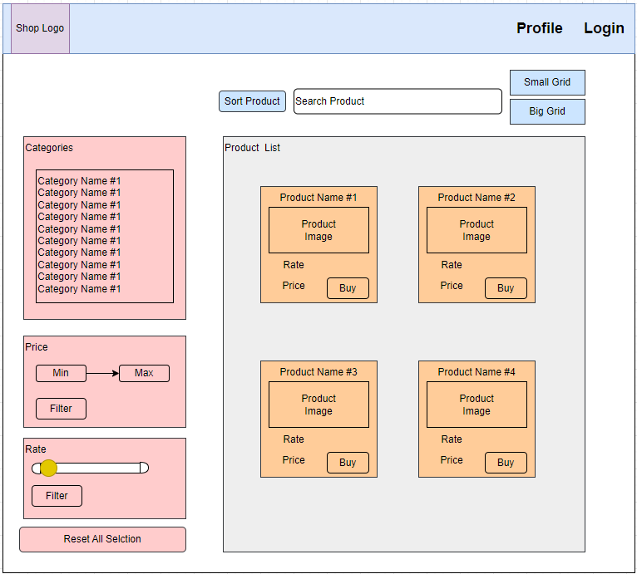

| **Field Name** | **Field Type** | **Description** |
| --- | --- | --- |
| **Login** | **Button** | **The user click the button to forward to the user login page** |
| **Shop Logo** | **Button** | **Click the logo to back to home page** |
| **Profile** | **Button** | **The user click the button to forward to the User Profile** |
| **Search Bar** | **Search Box** | **User type the product that they want to find** |
| **Sort** | **Button** | **Sort the Product from Rate or Price desc or asc** |
| **Big Grid** | **Button** | **Show the Big Grid Interface of the Shop** |
| **Small Gird** | **Button** | **Show the Small Grid Interface of the Shop** |
| **Product List** | **A list of Product contain Name, Price, Image and Rate** | **This Show to the User the products** |
| **Buy** | **Button** | **Go Directly to the Product Detail Page** |
| **Categories** | **A list of all kind of categories that the Shop have** | **The User click on each category to see the product** |
| **Price** | **Text Box** | **Type the range of the money that user affordable** |
| **Rate** | **Text Box** | **Select the Range of the Rate that the User want to find** |
| **Filter** | **Button** | **This Combine all the selection of the user including rate, price, categories, grid,...** |
| **Reset All** | **Button** | **Reset the selection to default** |

#### **Database Access**

| **Table** | **CRUD** | **Description** |
| --- | --- | --- |
| **Shop** | **R** | **List all Product**  **Sort the Product list order by Rate**  **Sort the Product list order by Price** |
| **Category** | **R** | **Display all category** |

***SQL Commands:***

**1/ List all Product**

**SELECT * FROM Product**

**2/ List all Category**

**Select “ FROM Category**

**3/ Sort Product (Price)**

**SELECT * FROM Product**

**order by price desc (order by price asc)**

**4/Sort Product (Rate)**

**SELECT * FROM Product**

**order by ratedesc (order by rate asc)**

### **2.3 Product Details**

#### **UI Design**

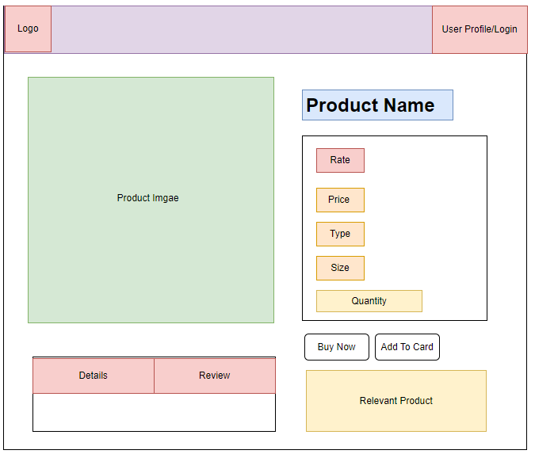

| **Field Name** | **Field Type** | **Description** |
| --- | --- | --- |
| **Logo** | **Button** | **Click the logo to back to home page** |
| **UserProfile/Login** | **Button** | **The user click the button to forward to the User Profile**  **If user not an User this will appear as Login** |
| **Product Image** | **Image** | **Show the main Image of this product** |
| **Porduct Name** | **Text Box**  **(read- only)** | **Show the Name of the Product** |
| **Details** | **Button** | **Show the describe of the Product** |
| **Review** | **Button** | **Show the review of the reviewer** |
| **Rate** | **Text Box**  **(read- only)** | **This Show the Rate of this product** |
| **Price** | **Text Box**  **(read- only)** | **Show the price of this product** |
| **Type/Size** | **Text Box**  **(read- only)** | **Show the type and size of the Product** |
| **Quantity** | **Button** | **User choose how many product they want to buy** |
| **Add to Cart** | **Button** | **User click to add this product into cart** |
| **Relevant Product** | **A list of Product** | **The Shop will recommend the Product that have that kind of Category** |
| **Buy Now** | **Button** | **Go Directly to the Checkout Page** |

#### **Database Access**

| **Table** | **CRUD** | **Description** |
| --- | --- | --- |
| **Shop** | **R** | **List all Product**  **Sort the Product list order by Rate**  **Sort the Product list order by Price** |
| **Category** | **R** | **Display all category** |

***SQL Commands:***

**1/ List all Product**

**SELECT * FROM Product where productID = ?**

### **2.4 People Profile**

#### **UI Design**

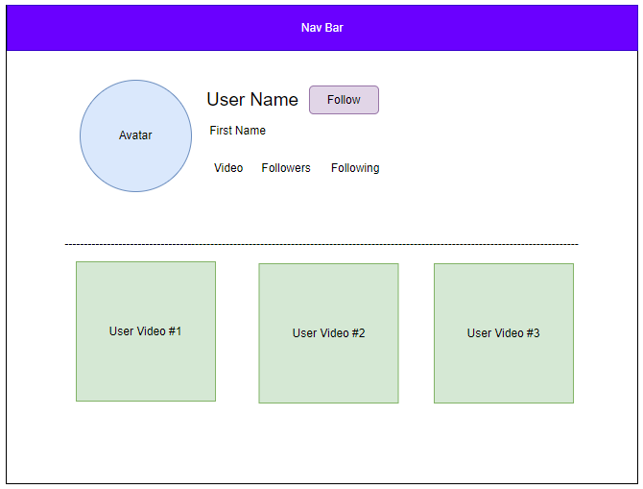

| **Field Name** | **Field Type** | **Description** |
| --- | --- | --- |
| **Avatar** | **Image** | **Show the User Profile** |
| **User Name** | **text(read-only)** | **Show User Name** |
| **First Name** | **text (read-only)** | **Show the User First Name** |
| **Video** | **text(read-only)** | **Show the number of videos** |
| **Followers** | **Button** | **Show the number and List of Followers** |
| **Following** | **Button** | **Show the number and List of Following** |
| **Videos** | **video** | **Show the Video by each VideoID** |

#### **Database Access**

| **Table** | **CRUD** | **Description** |
| --- | --- | --- |
| **Follow** | **C/R/D** | **check the Follow exist**  **insert into DataBase if hit Follow**  **delete the Follow attribute if hit Unfollow** |
| **User** | **R** | **Get User By UserID** |

***SQL Commands:***

**1/ Check Follow Exist**

**Select userID, followID from Follow where userID = ? And followID = ?**

**2/ Insert Into Follow Table**

**INSERT INTO [dbo].[Follow]\n"**

**+ " ([userID]\n"**

**+ " ,[followID])\n"**

**+ " VALUES\n"**

**+ " (?,?)"**

**3/Delete Into Follow Attribute**

**DELETE FROM [dbo].[Follow]\n"**

**+ " WHERE userID =?\n"**

**+ " AND followID=?"**

**4/ GetUserByUserID**

**select * from [User] where userID=?**

### **2.5 Shop Page**

#### **UI Design**

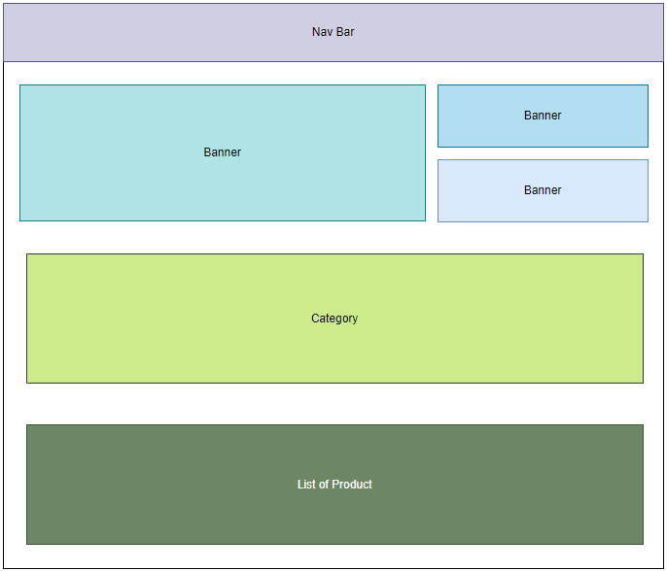

| **Field Name** | **Field Type** | **Description** |
| --- | --- | --- |
| **Banner** | **Image** | **Show the Banner** |
| **Category** | **List of Categories** | **Show Each Category to the main Shop** |
| **Product** | **List of Product** | **Show a list of Product order by rate or date** |
| **Price** | **Text Box** | **Type the range of the money that user affordable** |

#### **Database Access**

| **Table** | **CRUD** | **Description** |
| --- | --- | --- |
| **Product** | **R** | **List all Product**  **Sort the Product list order by Rate**  **Sort the Product list order by ProductID** |
| **Category** | **R** | **Display all category** |

***SQL Commands:***

**1/ List all Product**

**SELECT * FROM Product**

**2/ List all Category**

**Select “ FROM Category**

**3/ Sort Product (ProductID)**

**SELECT TOP 8 [productID]\n"**

**+ " ,[categoryID]\n"**

**+ " ,[image]\n"**

**+ " ,[detail]\n"**

**+ " ,[shopID]\n"**

**+ " ,[price]\n"**

**+ " ,[name]\n"**

**+ " ,[rate]\n"**

**+ "FROM [DuDu].[dbo].[Product]\n"**

**+ "ORDER BY [productID] DESC;**

**4/Sort Product (Rate)**

**SELECT * FROM Product**

**order by ratedesc (order by rate asc)**

## **3. User Features**

### **3.1 Upload Video**

#### **UI Design**

# 

| **Field Name** | **Field Type** | **Description** |
| --- | --- | --- |
| **Logo** | **Image** | **Show the Website Logo** |
| **Title** | **text** | **Enter the Title of the video** |
| **hastag** | **text** | **Enter the Hastag** |
| **Product** | **text-list** | **Show the Liast of User Product** |
| **Upload** | **Button** | **Upload to the HomePage** |

#### **Database Access**

| **Table** | **CRUD** | **Description** |
| --- | --- | --- |
| **videoDAO** | **C** | **Insert video or video with product** |

***SQL Commands:***

**1/ Insert video**

**INSERT INTO [dbo].[Video]\n"**

**+ "([title], [code], [hastag], [UserID])\n"**

**+ "VALUES (?, ?, ?, ?)**

**2/insert video and product**

**INSERT INTO [dbo].[Video]\n"**

**+ "([title], [code], [hastag], [UserID],[product_id])\n"**

**+ "VALUES (?, ?, ?, ?,?)**

### **3.2 Cart Details**

#### **UI Design**

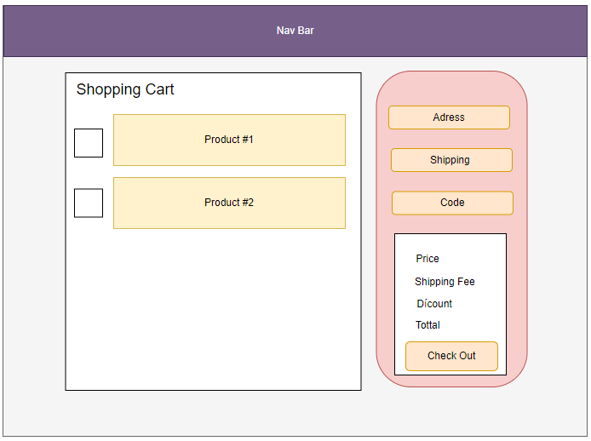

| **Field Name** | **Field Type** | **Description** |
| --- | --- | --- |
| **Product** | **List of Product** | **Show Each Product that be added to Cart** |
| **Address** | **text** | **User Enter Address** |
| **Shipping** | **Option** | **Choose Shipping Type** |
| **Code** | **Text Box** | **Enter the voucher code** |
| **Upload** | **Button** | **Hit to Check out** |

#### **Database Access**

| **Table** | **CRUD** | **Description** |
| --- | --- | --- |
| **ProductDAO** | **R** | **Get product by product id** |
| **CategoryDAO** | **R** | **Get Category by id** |
| **WarehouseDAO** | **R** | **getType and getSize** |
| **shopDAO** | **R** | **GetShopFromShopID** |
| **VoucherDAO** | **R** | **getVoucherbyCode** |

***SQL Commands:***

**1/ProductDAO**

**Select * from Product where productID = ?**

**2/CategoryDAO**

**Select * from Category where categoryID=?**

**3/getType**

**select distinct type from Warehouse where productID=?**

**4/getSize**

**select distinct size from Warehouse where productID=?**

**5/getShopByshopID**

**"SELECT [ShopID]\n"**

**+ " ,[name]\n"**

**+ " ,[userID]\n"**

**+ " ,[rate]\n"**

**+ " FROM [dbo].[Shop]"**

**+ " WHERE ShopID =**

**6/getVoucherByCode**

**select * from Voucher where code =?**

### **3.3 Check Out**

#### **UI Design**

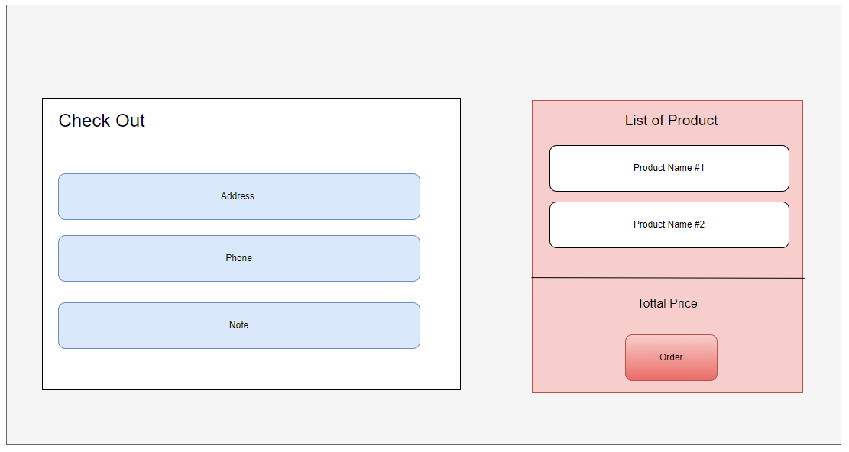

| **Field Name** | **Field Type** | **Description** |
| --- | --- | --- |
| **Product** | **List of Product** | **Show Each Product** |
| **Address** | **text** | **User Enter Address** |
| **Phone** | **Text-Box** | **Enter Phone number** |
| **Note** | **Text Box** | **Enter a message to the seller or shipper** |
| **Order** | **Button** | **Hit to Order** |

#### **Database Access**

| **Table** | **CRUD** | **Description** |
| --- | --- | --- |
| **ProductDAO** | **R** | **Get product by product id** |
| **CategoryDAO** | **R** | **Get Category by id** |
| **OrderDAO** | **R** | **createOrder** |
| **shopDAO** | **R** | **GetShopFromShopID** |
| **VoucherDAO** | **R** | **getVoucherbyCode** |

***SQL Commands:***

**1/ProductDAO**

**Select * from Product where productID = ?**

**2/CategoryDAO**

**Select * from Category where categoryID=?**

**3/createOrder**

**insert into [Order] (userID,total,date,address,note,ship,discount) values(?,?,?,?,?,?,?)**

**4/getShopByshopID**

**"SELECT [ShopID]\n"**

**+ " ,[name]\n"**

**+ " ,[userID]\n"**

**+ " ,[rate]\n"**

**+ " FROM [dbo].[Shop]"**

**+ " WHERE ShopID =**

**5/getVoucherByCode**

**select * from Voucher where code =?**

### **3.4 Check Out**

#### **UI Design**

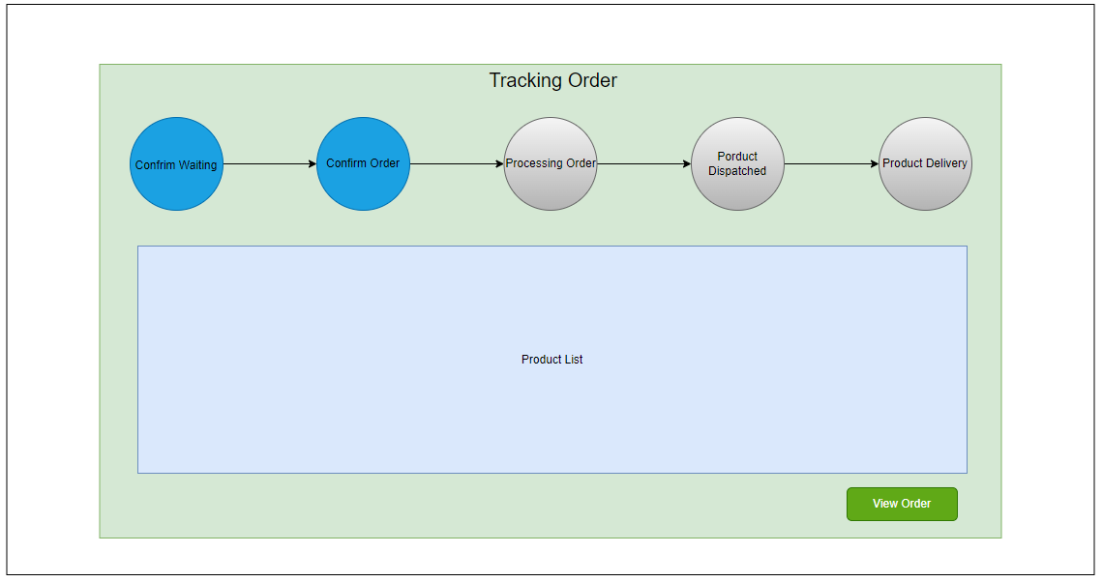

#### **Database Access**

| **Table** | **CRUD** | **Description** |
| --- | --- | --- |
| **ProductDAO** | **R** | **Get product by product id** |
| **OrderDAO** | **R** | **createOrder** |

***SQL Commands:***

**1/ProductDAO**

**Select * from Product where productID = ?**

**2/createOrder**

**insert into [Order] (userID,total,date,address,note,ship,discount) values(?,?,?,?,?,?,?)**

## **4. Seller Features**

### **4.1 Product Management**

#### **UI Design**

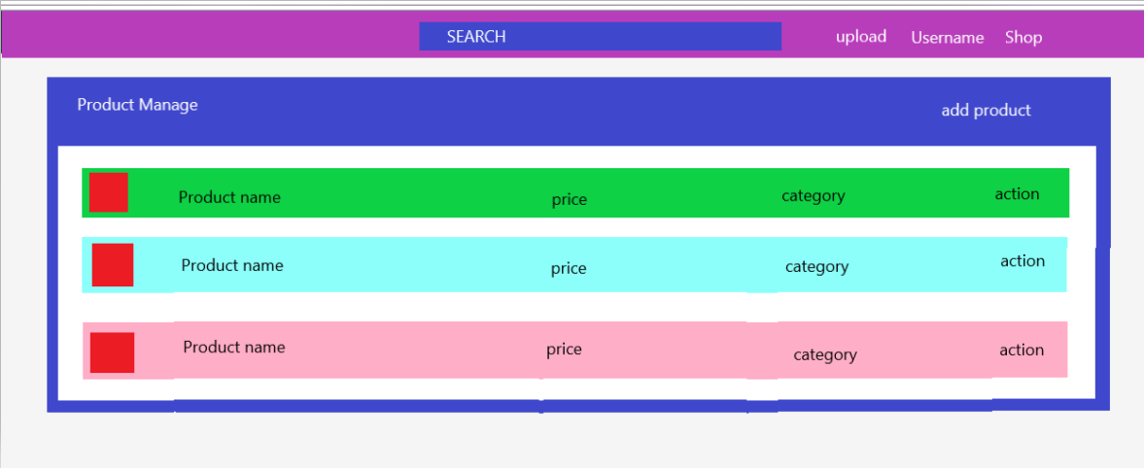

| **Field Name** | **Field Type** | **Description** |
| --- | --- | --- |
| **Upload** | **Button** | **After click on this the Website will change ti Upload Video** |
| **User Name** | **Button** | **Send directly to the User Profile Page** |
| **Add product** | **Button** | **Button to send direct to add product tab** |
| **Product Name** | **Text Box** | **Show the name of product** |
| **Price** | **Text Box** | **Show the price of product** |
| **Category** | **Text Box** | **Show the Category of product** |
| **Action** | **Button** | **To edit or delete the product** |

#### **Database Access**

| **Table** | **CRUD** | **Description** |
| --- | --- | --- |
| **Product** | **CRUD** | **Add, edit,delete product** |
| **Ware House** | **CRUD** | **Add, edit,delete Image Ware House** |
| **Images** | **CRUD** | **Add, edit,delete Image Product** |

***SQL Commands:***

**1/ Add a Product to the database**

**INSERT INTO [dbo].[Product] ([categoryID] ,[type] ,[image] ,[detail] ,[rate] ,[size] ,[shopID] ,[price] ,[name])**

**VALUES (" “p.getCategory()”,”getCategoryID()” ,” p.getImage()” ,” p.getDetail()” ," p.getRate() "" ," p.getShop()”,”p.getShopID() “," p.getPrice() "," p.getName() "')";**

**2/ Delete product**

**DELETE FROM [dbo].[Product] WHERE productID = " id "**

**3/ Update Product**

**UPDATE [dbo].[Product]**

**SET [categoryID] = p.getCategory().getCategoryID()**

**,[image] = p.getImage()**

**,[detail] = p.getDetail()**

**,[rate] = p.getRate()**

**,[shopID] = p.getShop().getShopID()**

**,[price] = p.getPrice()**

**,[name] = 'p.getName()**

**WHERE productID = p.getProductID()**

### **4.2 Shop Management**

#### **UI Design**

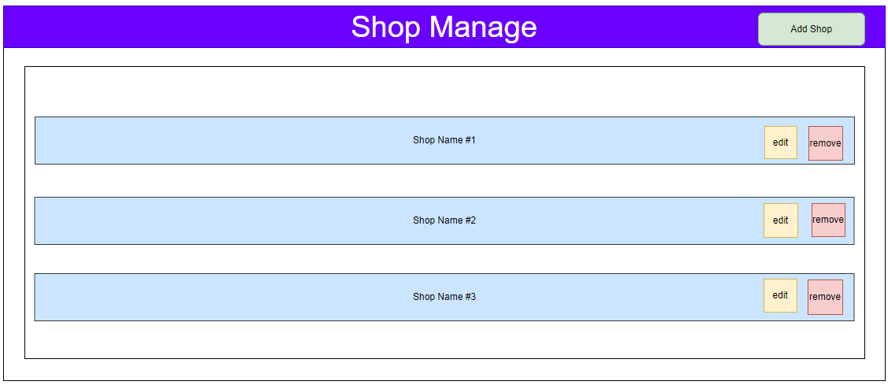

| **Field Name** | **Field Type** | **Description** |
| --- | --- | --- |
| **Shop Name** | **List of Shop** | **A List of User’s Shop** |
| **Remove** | **Button** | **Delete Shop** |
| **Edit** | **Button** | **Update Shop** |
| **Add Shop** | **Button** | **Insert a new Shop** |

#### **Database Access**

| **Table** | **CRUD** | **Description** |
| --- | --- | --- |
| **ShopDAO** | **CRUD** | **Add, edit,delete Shop** |

***SQL Commands:***

**1/ updateShop()**

**UPDATE [dbo].[Shop]\n"**

**+ " SET [name] = '" + Shop.getName() + "'\n"**

**+ " ,[userID] = " + Shop.getUser().getUserID() + "\n"**

**+ " ,[rate] = " + Shop.getRate() + "\n"**

**+ " WHERE ShopID = " + Shop.getShopID() + ""**

**2/AddShop**

**INSERT INTO [dbo].[Shop]\n"**

**+ " ([name]\n"**

**+ " ,[userID]\n"**

**+ " ,[rate])\n"**

**+ " VALUES\n"**

**+ " (" + Shop.getName() + "\n"**

**+ " ," + Shop.getUser().getUserID() + "\n"**

**+ " ," + Shop.getRate() + ")"**

**3/DeleteShopByID**

**"DELETE FROM [dbo].[Shop]\n"**

**+ " WHERE id = "+ id +" "**

### **4.3 WareHouse Management**

#### **UI Design**

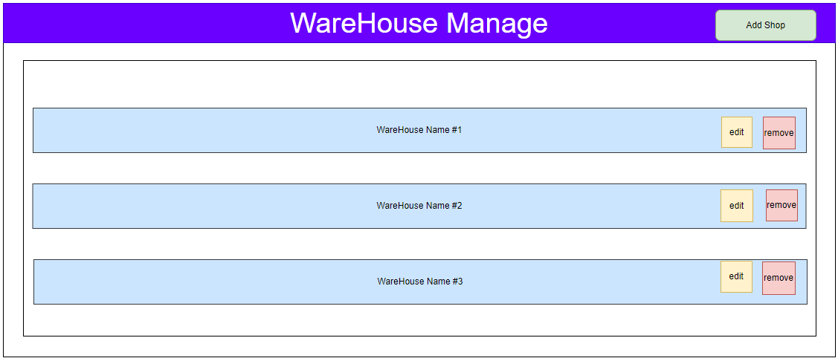

| **Field Name** | **Field Type** | **Description** |
| --- | --- | --- |
| **WareHouse Name** | **List of WareHouse** | **A List of WareHouse** |
| **Remove** | **Button** | **Delete WareHouse** |
| **Edit** | **Button** | **Update WareHouse** |
| **Add Shop** | **Button** | **Insert a new WareHouse** |

#### **Database Access**

| **Table** | **CRUD** | **Description** |
| --- | --- | --- |
| **WareHouseDAO** | **CRUD** | **Add, edit,delete WareHouse** |

**1/InsertWareHouse**

**INSERT INTO [dbo].[Warehouse]**

**([productID]**

**,[type]**

**,[size]**

**,[quantity])**

**VALUES**

**(?,?,?,?)**

**2/UpdateWareHouse  
UPDATE [dbo].[Warehouse]**

**SET [productID] = ?**

**,[type] = ?**

**,[size] = ?**

**,[quantity] = ?**

**WHERE warehouseID=?**

**3/ deleteWareHouse**

**DELETE FROM [dbo].[Warehouse]**

**WHERE warehouseID=?**

***SQL Commands:***

## **5. Admin Features**

### **5.1 Ban User**

#### **UI Design**

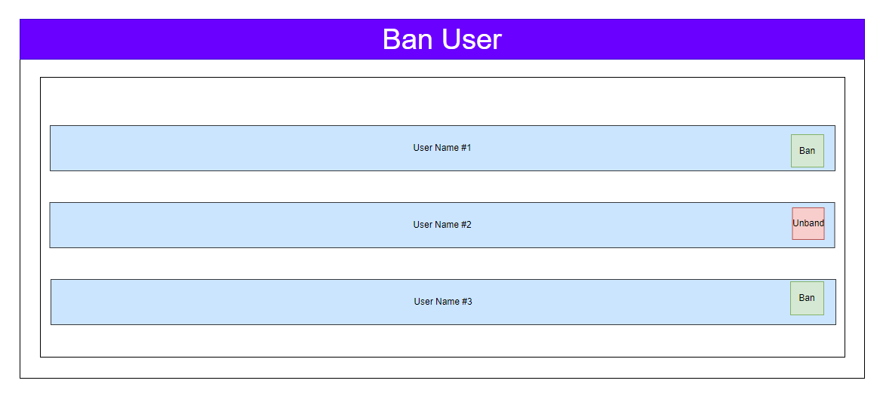

| **Field Name** | **Field Type** | **Description** |
| --- | --- | --- |
| **User Name** | **List of Users** | **A List of User’s Infomation** |
| **Ban** | **Button** | **Set Role to 3 or 4** |
| **Unban** | **Button** | **if Role =3 return Role to 1 if Role = 4 return Role to 2** |

#### **Database Access**

| **Table** | **CRUD** | **Description** |
| --- | --- | --- |
| **UserDAO** | **U** | **UpdateRole** |

***SQL Commands:***

**1/BanUser**

**SELECT [role]\n"**

**+ " FROM [dbo].[User]\n"**

**+ " Where userID = " + id**

**UPDATE [dbo].[User]\n"**

**+ " SET [role] = " + role + "\n"**

**+ " WHERE userID =" + id**

**2/UnBanUser**

**SELECT [role]\n"**

**+ " FROM [dbo].[User]\n"**

**+ " Where userID = " + id + ""**

**UPDATE [dbo].[User]\n"**

**+ " SET [role] = " + role + "\n"**

**+ " WHERE userID =" + id**

# **IV. Appendix**

## **1. Assumptions & Dependencies**

AS-1: There is a demand for a social media-integrated online shopping system, presenting a market opportunity for the proposed platform.

AS-2: Users are willing to pay for unique features of the platform and prefer the flexibility of online shopping.

AS-3: Collaboration with reliable partners, brands, and stores is feasible and will ensure diversity and quality in the offered products.

AS-4: The platform's interface and functionality will meet user expectations and provide a positive shopping experience.

AS-5: Marketing and promotional strategies will be implemented to attract and retain a substantial user base.

DE-1: Reliable technological infrastructure, including servers, databases, and internet connectivity, is available to support the platform's operations.

DE-2: Collaboration and partnerships with brands and stores to ensure a diverse and high-quality product range on the platform.

DE-3: Integration with secure payment gateways and financial services to facilitate convenient payment processes during online shopping.

DE-4: Access to product management tools to ensure a smooth and convenient shopping experience.

DE-5: Compliance with legal regulations and protection of privacy rights related to online shopping transactions and the use of personal data.

## **2. Limitations & Exclusions**

LI1: Geographic Coverage: Our online shopping and social media platform may not be available in all countries, territories, or regions due to local legal, regulatory, and technical constraints. Availability and support may be restricted accordingly.

LI2: Technical Prerequisites: To make the most of our online shopping and social media experience, users are required to meet certain technical specifications. These include a stable internet connection, compatible devices, and the use of specified supporting software. Failure to meet these requirements may impact users' ability to access and utilize our platform effectively.

LI3: User Constraints: Our platform may impose limitations on the number of users or registrations within specific time frames. These limitations are in place to optimize performance, enhance user experience, and manage system resources effectively, ensuring scalability.

LI4: Customized Features: Certain functionalities within our online shopping and social media platform may be subject to optional restrictions based on customer preferences or specific development environments. Features can be tailored or extended to meet the unique requirements of each organization or customer.

LI5: Security and Privacy Measures: While we prioritize security and privacy in our online environment, it's important to note that absolute certainty cannot be guaranteed. Users are advised to be aware of and accept potential risks associated with sharing personal information and engaging on our platform. We adhere to security and privacy regulations to the best extent possible.

## **3. Business Rules**

## 

| Business Rules ID | Category | Business Rules |
| --- | --- | --- |
| BR-1 | Constraints | - Admin can view a list of registered users. |
| BR-1 | Constraints | - Admin can check and suspend sellers with poor feedback or complaints. |
| BR-1 | Constraints | - Users, shop owners, and admin can log in using email and password. |
| BR-1 | Constraints | - Users must provide valid registration information. |
| BR-5 | Action Enablers | - Users can reset their password using their email address. |
| BR-6 | Action Enablers | - Users can change their password after logging in. |
| BR-7 | Constraints | - Users can log in or register with Google. |
| BR-8 | Facts | - Display sliders, products, and posts on the shop page. |
| BR-9 | Facts | - Display a paginated list of products with sorting and filtering options. |
| BR-10 | Facts | - Display detailed information about a product. |
| BR-11 | Facts | - Users can add hashtags to their videos and view videos with the same hashtag. |
| BR-12 | Facts | - Show video clips uploaded by users and shop owners with relevant information. |
| BR-13 | Facts | - Display comments on videos and their respective like counts. |
| BR-14 | Facts | - Display information about other users' profiles. |
| BR-15 | Facts | - Group videos with hashtags and allow users to explore videos by their interests. |
| BR-16 | Facts | - Users can view statistics on the number of views, likes, and comments in their videos. |
| BR-17 | Facts | - Display a list of shops owned by the user with options to add, edit, or delete shops. |
| BR-18 | Facts | - Display a paginated list of feedbacks with filtering and sorting options. |
| BR-19 | Facts | - Display trends in orders, revenues, customers, and feedbacks. |
| BR-20 | Facts | - Display a paginated list of orders with filtering, sorting, and status changing options. |
| BR-21 | Facts | - Display detailed information about an order and allow status changes. |
| BR-22 | Facts | - Display statistics and trends for shop owners, including orders, revenues, and feedbacks. |
| BR-23 | Facts | - Allow shop owners to provide coupons to potential buyers. |
| BR-24 | Constraints | - Shop owners can link videos to their products. |
| BR-25 | Facts | - Display the user's chosen products, their quantities, and allow changes. |
| BR-26 | Facts | - Display chosen products and receiver information for order confirmation. |
| BR-27 | Facts | - Display order completion notes and send order confirmation emails. |
| BR-28 | Facts | - Users can give feedback on received products. |
| BR-29 | Facts | - Display a list of users' orders with status filtering options. |
| BR-30 | Facts | - Display detailed information about an order. |
| BR-31 | Facts | - Users can edit their profile information and change their roles. |
| BR-32 | Constraints | - Implement authorization mechanisms based on the user's role. |
| BR-33 | Constraints | - Users receive email notifications about relevant events. |
| BR-34 | Facts | - Users can follow other users, increasing follower and following counts. |
| BR-35 | Facts | - Users can block other accounts, preventing videos and access to the blocked account. |
| BR-36 | Facts | - Users can report sellers for review by the admin. |
| BR-37 | Facts | - Display user profile information, videos, followers, following, and blocked users. |
| BR-38 | Facts | - Users can upload videos with titles, hashtags, and product links. |
| BR-39 | Facts | - Users can manage their uploaded videos by editing or deleting them. |
| BR-40 | Facts | - Users can view statistics on the number of views, likes, and comments in their videos. |
| BR-41 | Facts | - Users can send and receive messages from other users and shop owners. |

## 